Banknote Sorter
BCS-160
User Manual
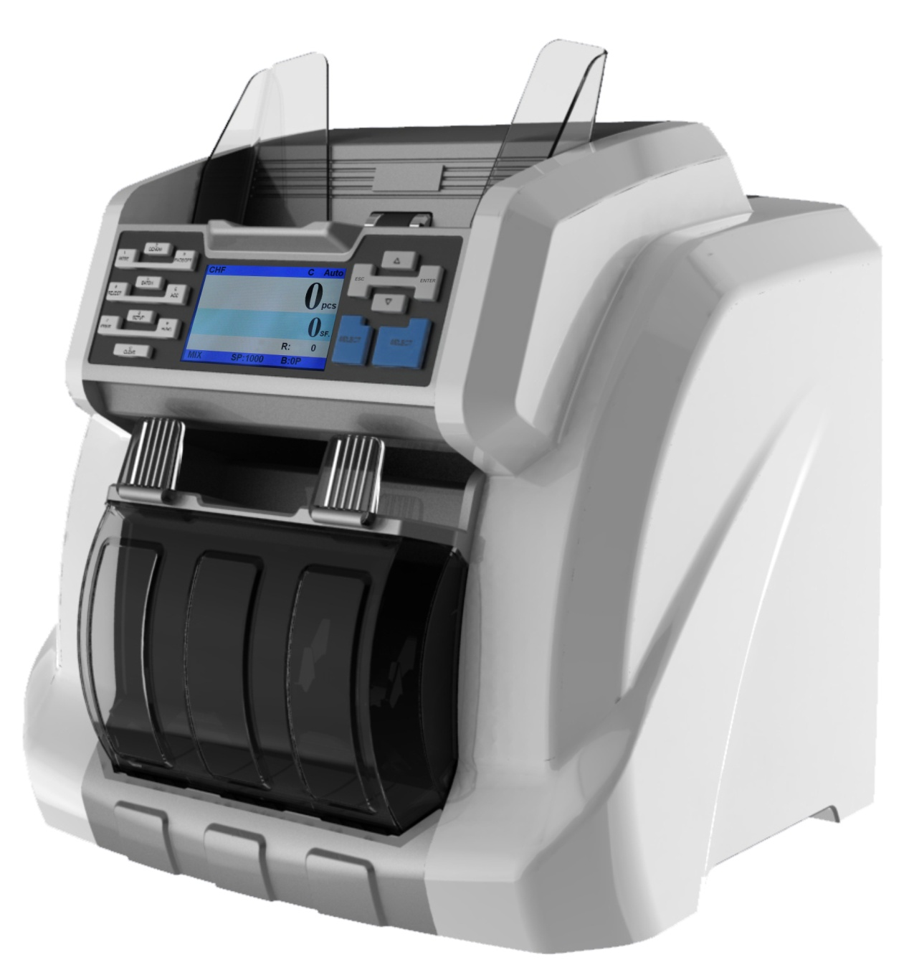

Contents
Contents 1
1. Introduction 3
1.1 Preface 3
1.2 Notice 3
2. Installation Notice 4
2.1 Installation Notice 4
2.2 Installation place notice 4
3. Appearance 5
3.1 Front Appearance 5
3.2 Back Appearance 5
4. Specification 6
5. Display and Operation interface 7
5.1 Software Interface Explanation 7
5.2 Key Function Explanation 7
6. Operation Instruction 8
6.1 Turn on the machine 8
6.2 Selection of Counting Mode 8
6.2.1 Single Currency Counting Mode 8
6.2.2 Automatic Recognition Mode(Optional function) 11
6.2.3 Multi-currency Mix Counting Mode (Optional function) 12
6.3 Quantity Batch and Amount Batch Setting 13
6.4 Face/Orientation Sorting Setting 15
6.5 Counting Speed Setting 16
6.6 Accumulation Function 16
7. Check counting result and printing information 16
7.1 Check counting result 16
7.2 Check Suspected Notes Details and Serial Number 17
7.3 Printing Information 19
8. User Setting 19
8.1 Counterfeit Detection Setting 20
8.2 Double banknotes detection setting 24
8.3 Banknote version sorting setting 24
8.4 Banknote information collection 25
8.5 Basic setting 29
8.6 Sensitivity Setting for QT sensor 35
9. Troubleshooting 36
9.1 Common errors 36
9.2 Banknote jamming and solution 37
10. Software Upgrade 38
10.1 MAINBOARD upgrading 38
10.2 IMAGEBOARD upgrading 39
11. Image Collection through PC 40
11.1 Configure the IP address of PC 40
11.2 Configure the IP Address 40
11.3 Notes collection 41
11.4 Notes 44
12. How to check the counting list 45
13. Daily Maintenance 47
13.1 Clean the hopper sensor 47
13.2 Clean the drum roller shaft and feed roller shaft 47
13.3 Clean the leak sensor 48
13.4 Clean the inside sensor 48
14. Accessories 53

1. Introduction

1.1 Preface
Thanks for buying our product. The user manual includes the operation steps and matters need attention.
In order to use the machine correctly, please read this manual carefully. If you meet any difficulty please contact your local distributor immediately.
We keep the right to modify the content of the manual without notice.

1.2 Notice
This product is used to sort and count banknotes ,If any loss caused due to incorrect use, or any modification to the machine not done by our company or our distributor, our company will not be responsible for it. Please contact your distributor if you want to install or transport this machine to avoid the wrong installation or damage during the transportation.
- This product is used for counting and sorting the mentioned banknotes in user manual. Please don’t use this machine for other purpose.
- Due to different power supply standard and safety standard, please do not use this machine in countries with disaccorded power supply.
- Some content may be modified without notification, please kindly understand.
- We are working continuously for improving the quality of products, so the actual machine may be a little different with the manual.
- If the machine is changed or modified by user without our notice, our company will not be responsible for it.
- This machine is specially designed for indoor use. Please do not install or use it outdoors.
- Please do not install it in places that cannot bear the weight of this product or in places that are inclined or uneven.
- Do not use or place combustible materials, inflammables and volatile items such as thinners around/inside this product.
- Do not use this product in an excessively humid environment.
- Please avoid strong light and strong magnetic field interference.

2. Installation Notice

2.1 Installation Notice
- If you need to install this product, please contact the nearest distributor or our authorized distributor.
- The machine is only suitable for indoor use, please do not install it and use it outdoor.
- Please install the machine in an even place which can hold the weight of this machine.
- Please do not use or put flammable or volatile items around the machine, such as diluents.

2.2 Installation place notice
Install the machine as below, there should be enough space for your operation, such as putting the notes, opening and closing the cover and doing maintenance.
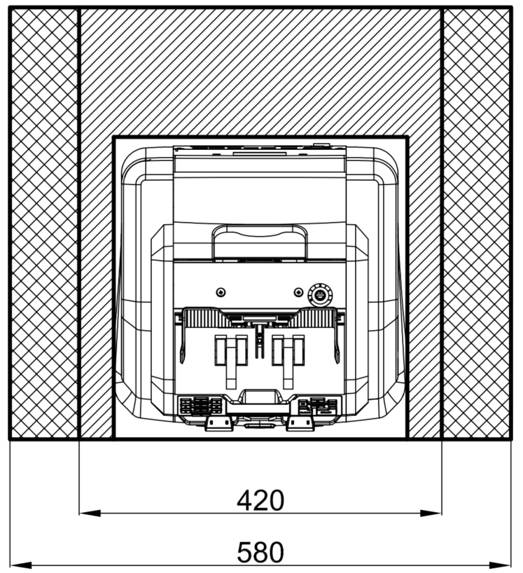
Installation space
Maintenance space
Measurement (mm)

3. Appearance

3.1 Front Appearance
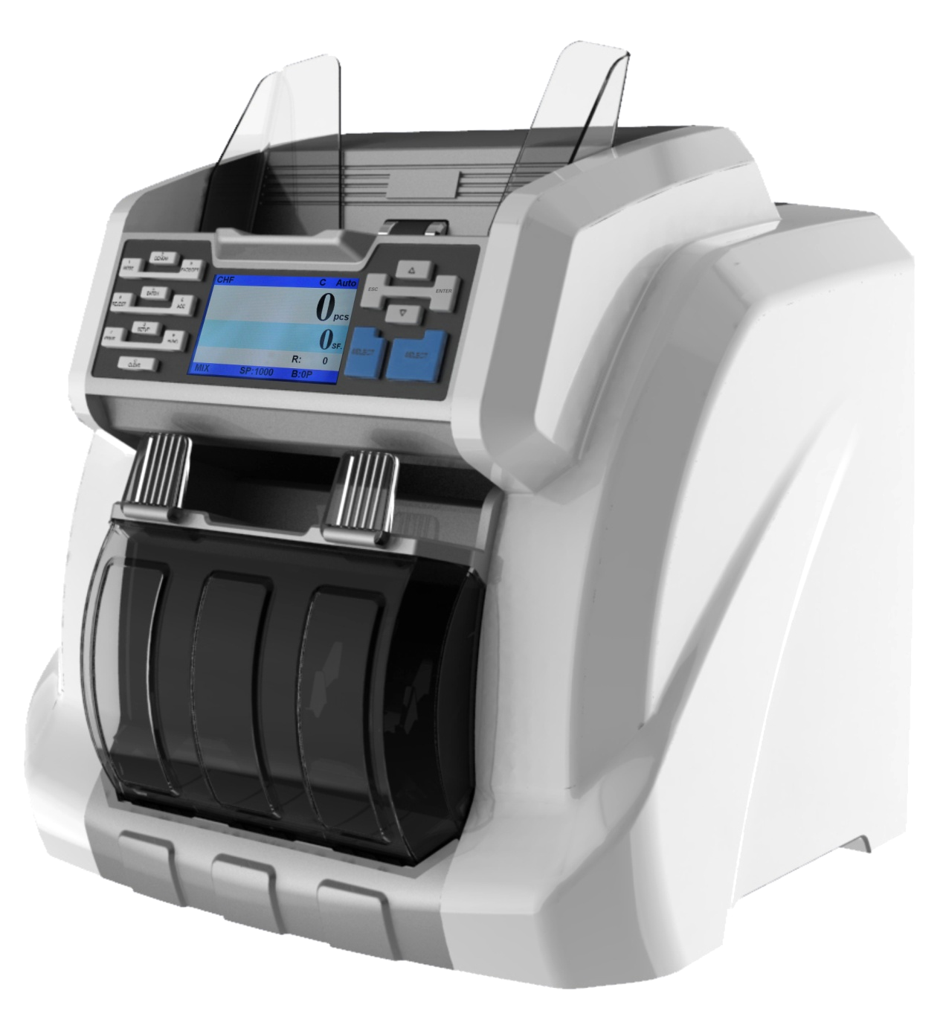
Reject Pocket
Hopper Extender
Stacker
Key Button
Display
Hopper

3.2 Back Appearance
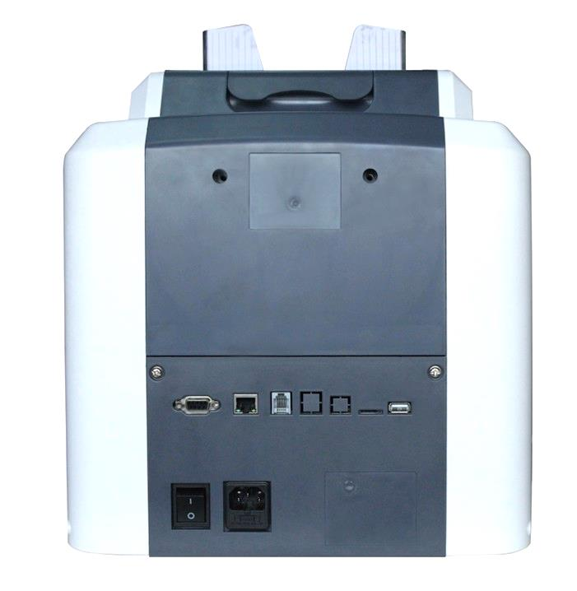
LAN Port(Option)
USB interface

SD card
RJ12
1.External printer
2.Terminal interface

Back Cover Open button
Feed Gap Adjusting Screw
Power Socket
Power Switch

4. Specification
Dimension(W×L×H) | 340mm×340mm×380mm
Weight | 13KG
Hopper Capacity | 600pcs
Stacker | 200pcs
Reject Pocket Capacity | 100pcs(brand new)
Display | 3.5 inch TFT Screen
Interface | RS-232/LAN/RJ12/SD/USB
Currency Support | Maximum 14 currencies
Sortable Notes Size | Length: 100mm~180mm  Width: 50mm ~90mm
Sortable Notes Thickness | 0.05mm~0.12mm
Counting Speed | 800/1000pcs/min (MIX/SDC mode)  800/1000/1200pcs/min (CNT modes)
Sorting Modes | MIX Counting Mode, FACE Sorting Mode,  Denomination Sorting Mode, Orientation Sorting Mode, Pieces Counting Mode
Batch No. | 0~200
Counterfeit Detection | UV/MG/MT/IR
Power Supply | AC 220V 50Hz ±10%  AC 110V 60Hz ±10%
Power Consumption | Sleeping Mode ≤15W  During Operation ≤70W
Working Condition | Temperature(0~40°C)/Humidity(40~90%)  Air Pressure(70-106kpa)
Storing Condition | Temperature(-40~55°C)/Humidity(10~95%)  Air Pressure(70-106kpa)

5. Display and Operation interface

5.1 Software Interface Explanation
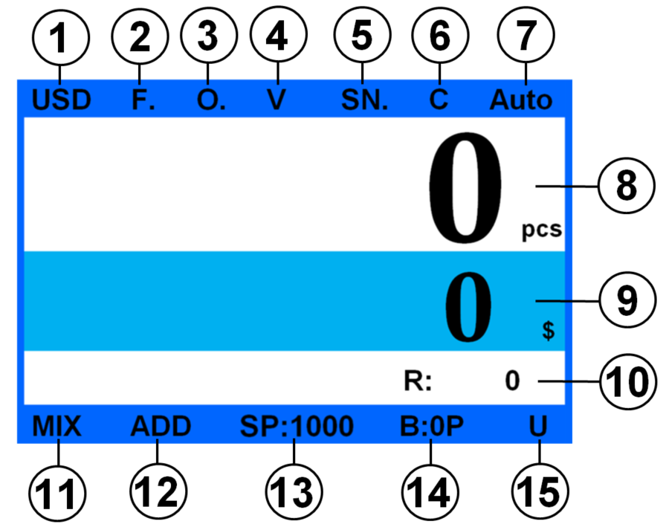
1. Currency Code
2. Face Sorting
3. Orientation Sorting
4. Version Sorting
5. Serial Number
6. Dustproof Cover ON/OFF
7. Auto Mode
8. Qty of Notes
9. Notes Amount
10. Qty of Suspected Notes
11. Operation Modes
12. Accumulation Mode
13. Counting Speed
14. Batch
15. USB is connected

5.2 Key Function Explanation
 | Currency selection and numeric key 1 | 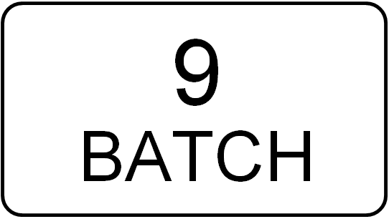 | Quantity/Amount batch or numeric key 9
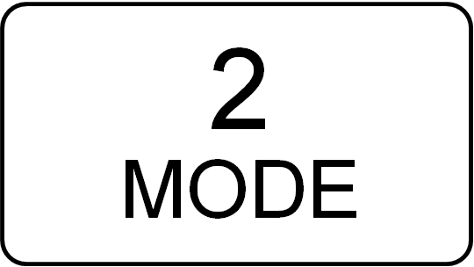 | Counting modes selection or numeric key 2 | 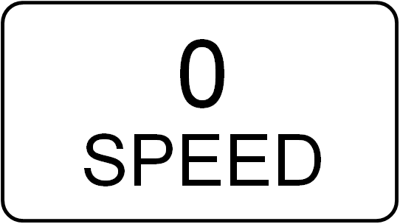 | Speed selection or numeric key 0
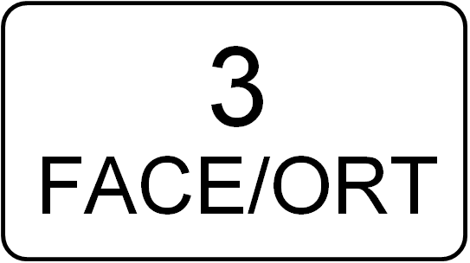 | Face/Orientation selection or numeric key 3 |  | Move the cursor up
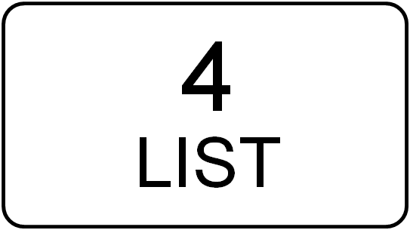 | Check counting details or numeric key 4 |  | Move the cursor down
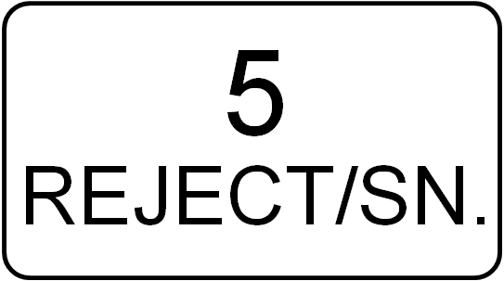 | Suspected notes checking and serial number checking or numeric key 5 |  | Exit or Cancel or Return
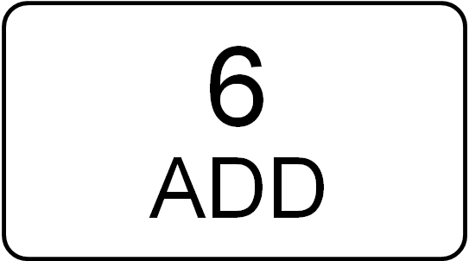 | Accumulation function switch or numeric key 6 |  | Function enter or confirmation or Save
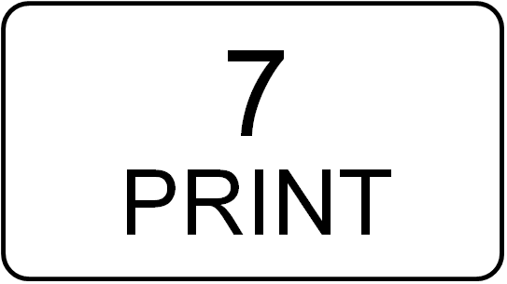 | Printing or numeric key 7 |  | Clear function or error code
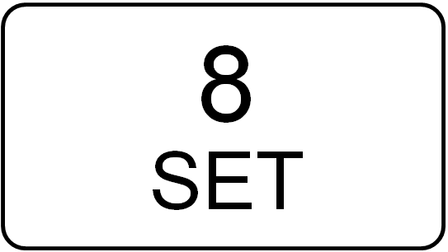 | User setting or numeric key 8 |  | Start the machine manually

6. Operation Instruction

6.1 Turn on the machine
Connect the machine with power supply and turn on the machine, the machine will enter into loading interface and self-testing interface, as shown in Figure 1. Please wait for about 1min and the machine will initialize successfully and enter into main interface as Figure 2.
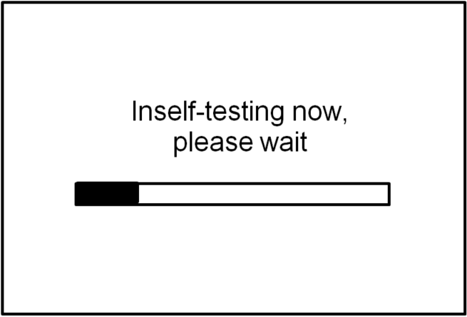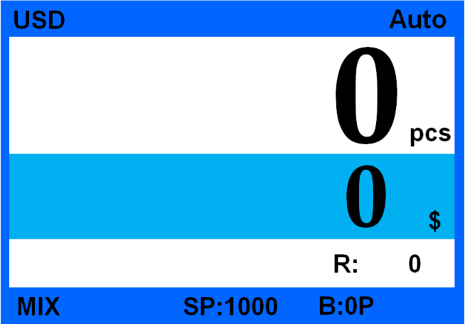
Figure 1 Figure 2

6.2 Selection of Counting Mode

6.2.1 Single Currency Counting Mode
*Note：Before counting please check the currency code area and confirm is the currency is correct, if not, please adjust the currency according to below instructions (take USD for example).
Press “1 CURRENCY” key to enter into currency selection mode, as shown in Figure 3.
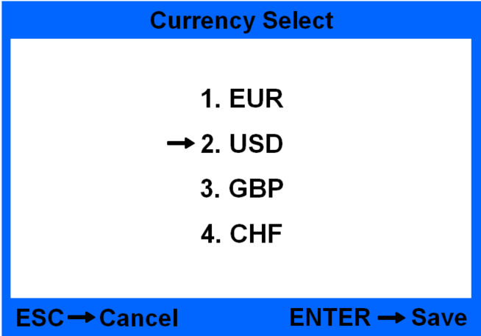
Figure 3
Under currency selection interface, and then move the arrow key to move the cursor to select the currency, press “ENTER” key to save the setting and return to main interface; if press ESC key, then it will not save the setting and return to main interface.(Figure 4 is to select the currency to be USD)
Figure 4
If the machine you ordered is with single currency, then it is not possible to select currency.
Press “2 MODE” key to switch 3 counting modes in circle. Under every mode the machine will operate under default setting, the modes order is MIX→SDC→CNT as Figure 5 shows, if default setting needs to be adjust please refer to User Setting.
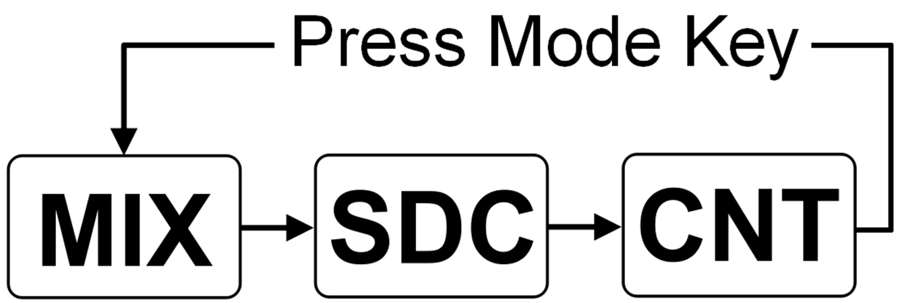
Figure 5
6.2.1.1<MIX> MIX COUNTING MODE
The Figure 6 shows the Mix counting mode under auto state, under this mode, the machine will keep the detailed information of notes in stacker including total quantity and total amount and detailed information for notes in reject pocket. Under this mode, the machine will count notes under a default speed at 1000pcs/min and detect the notes in a strict way.
Figure 6
6.2.1.2 <SDC> Single Denomination Counting Mode
The Figure 7 shows the machine in SDC mode under auto state. Under this mode, the machine will sort the notes according to the first note it counts , in the meantime, it will calculate and save the total amount, total quantity in stacker and quantity in reject pocket. Note: the notes rejected under this mode will give a size error code reminding. The default speed under this mode is 1000pcs/min and the counterfeit detection level is same as MIX mode.
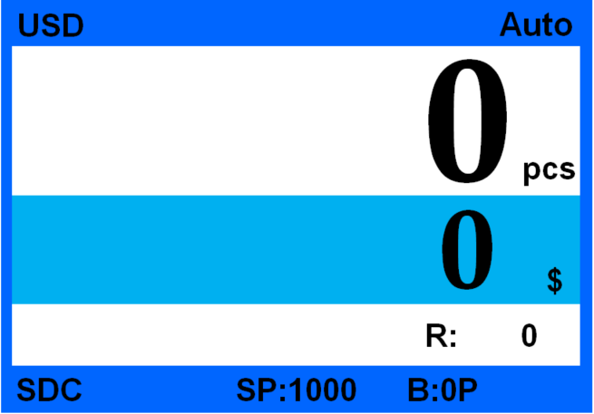
Figure 7
6.2.1.3 <CNT> Pieces Counting Mode
The Figure 8 shows the CNT mode under auto state, the machine only calculate the quantity of notes regardless currencies. Under this mode, the machine will count the notes in a default speed at 1000pcs/min without counterfeit detection, but the machine has DB detection, based on the thickness of first note, the machine possibly reject some notes due to different thickness. So under CNT mode with DB function ON, the machine is more suitable for counting the same denomination of same currency. In order to ensure the smooth counting, we suggest to turn off the DB function. For more detailed information please refer to User Setting.
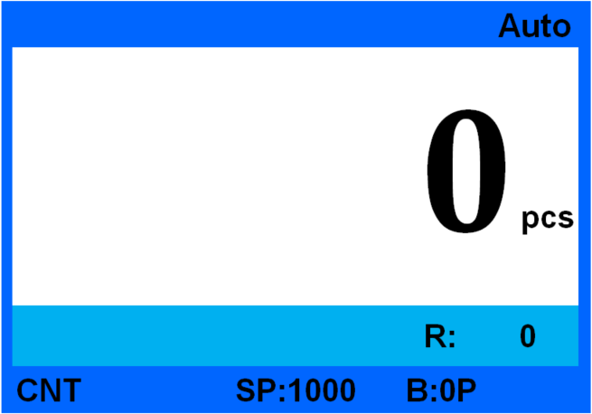
Figure 8

6.2.2 Automatic Recognition Mode(Optional function)
Automatic recognition: Refers to the automatic recognition of banknote counting mode. In the process of counting banknotes, the machine uses the first banknote passing through the sensor as the judgment rule to recognize banknotes of all denominations of the same country. When banknotes from other countries are recognized, the machine will alarm and stop. At this time, banknotes from other countries need to be taken out, and the machine will continue counting. The machine can only recognize the currency of the country displayed in the program.
Press “1 CURRENCY” key to enter into currency selection mode, as shown in Figure 9, and then move the arrow key to move the cursor to select “Auto”, press “ENTER” key to save the setting and return to main interface, as shown in Figure 10.
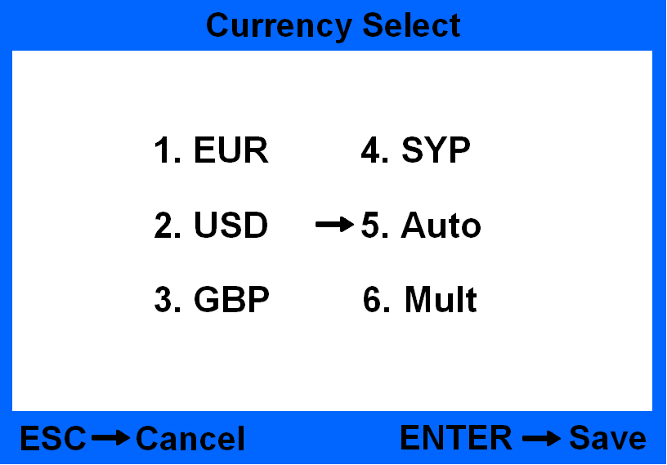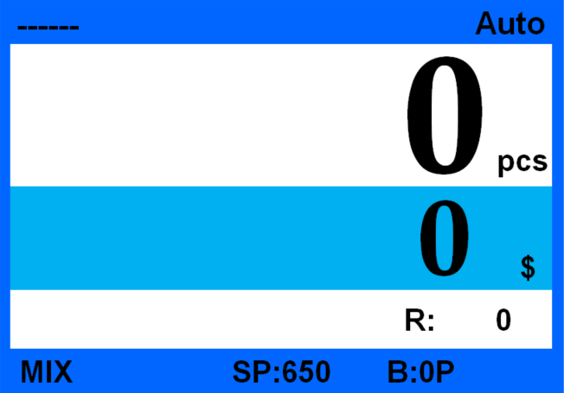
Figure 9 Figure 10
When the machine is in automatic recognition mode, it is recommended that you select the counting mode as "mix" mixed counting mode.
For example：Take a some dollar bills and put them into the machine for counting. The machine automatically recognizes the national currency as US dollar, and the currency symbol "- USD -" appears in the upper left corner, as shown in Figure 11 below.
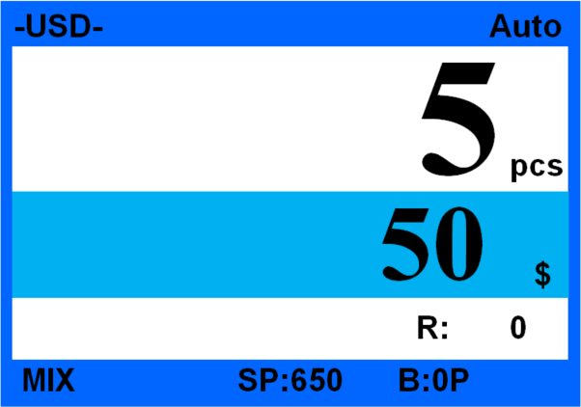
Figure 11
When you don't take the US dollars from the normal stacker, take other currencies (such as Euro) and put them into the machine for counting. Since the currency recognized by the machine this time is US dollars, the machine reports an error when listing euros.
After you take the US dollars from the normal stacker, take other currencies (such as Euro) and put them into the machine for counting. The machine automatically recognizes the current national currency, and the currency symbol "- EUR -" appears in the upper left corner, as shown in Figure 12 below:
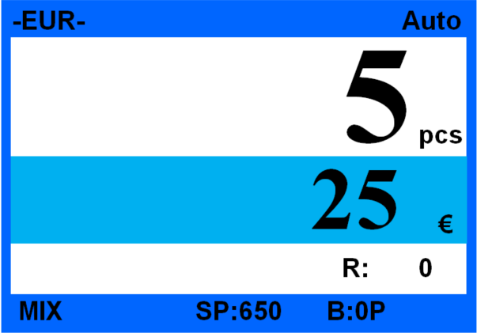
Figure 12

6.2.3 Multi-currency Mix Counting Mode (Optional function)
Multi-currency Mix Counting: Banknotes from multiple countries are mixed together and put into a machine to count. The machine can recognize all the currencies displayed on display.
Press “1 CURRENCY” key to enter into currency selection mode, as shown in Figure 13, and then move the arrow key to move the cursor to select “Mult”, press “ENTER” key to save the setting and return to main interface, as shown in Figure 14.
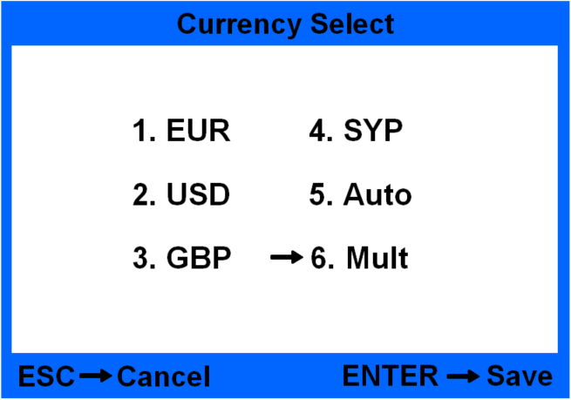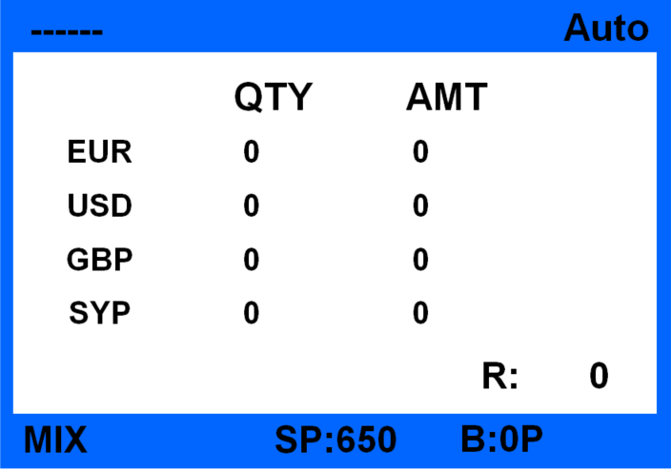
Figure 13 Figure 14
Example: put some banknotes (including EUR,USD,GBP,SYP) into the machine for counting. The display interface after counting is shown in Figure 15 below:
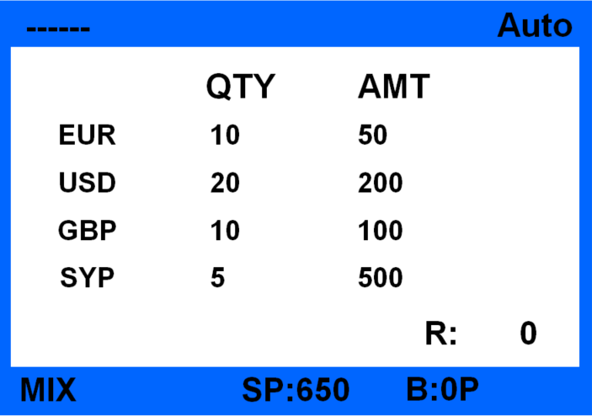
Figure 15

6.3 Quantity Batch and Amount Batch Setting
Under counting interface press “9 BATCH” key to enter into Quantity Batch setting interface as Figure 16：
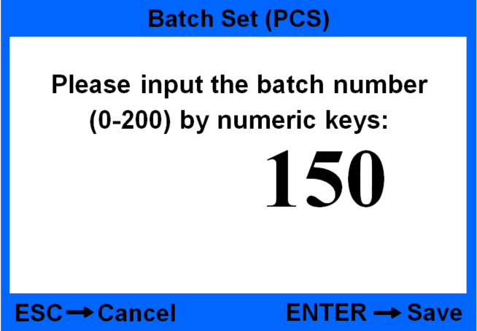
Figure 16
Under Quantity batch setting interface, press the numeric key to set the desired batch, press ENTER key to save setting and exit, the main interface will highlight show the quantity (for example B:150P means the batch quantity is 150), shown as Figure 70. If it is B:0P, it means the machine will stop automatically when it counts 200pcs notes.
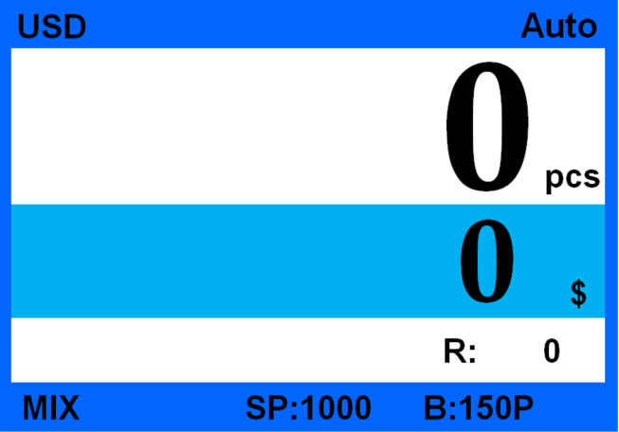
Figure 17
Amount Batch(this is only suitable for MIX mode, under SDC and CNT mode, the Figure 4 interface will not show the B:0P, and can not switch batch mode by press arrow key). Under Quantity Batch setting mode press “” key to enter into Amount Batch setting interface.
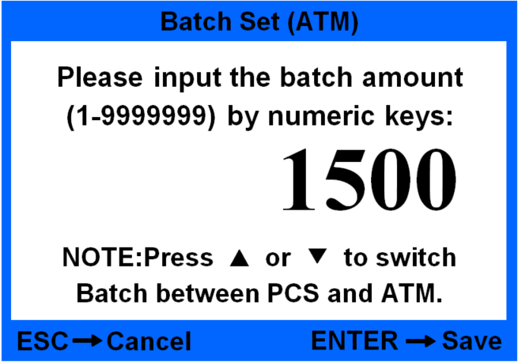
Figure 18
According to the interface prompt please press numeric key to batch amount (1-9999999). After setting press ENTER key to save and exit, the main interface will show B:1500A (it means the amount batch is set at 1500); After setting if press ESC key, the setting is invalid and will not be saved.

6.4 Face/Orientation Sorting Setting
This function is only valid for MIX/SDC mode, the user can settle the face/orientation by pressing “3 FACE/ORT” key. Press one time, the main interface will show F.，press two times it will show O.，press three times it will show F.O., press again to turn off this function. When F. Is turned on, the banknotes with the same face will go to stacker; When O. Is turned on, the same orientation banknotes will go to stacker; When F.O. Is turned on at the same time, the banknotes with same face and same orientation will go to stacker. The F.And O. Will highlight on the interface, the Figure 19 shows the machine is under MIX counting mode with face and orientation sorting function turned on.
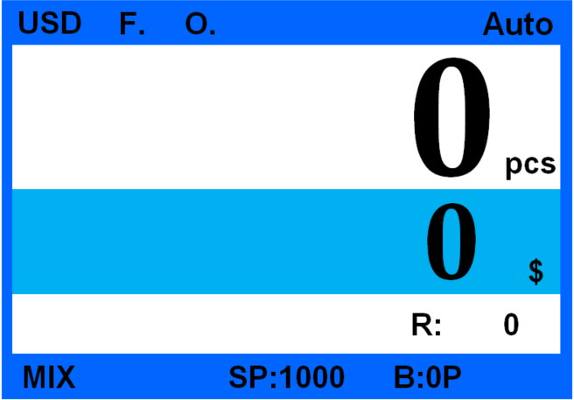
Figure 19

6.5 Counting Speed Setting
The counting speeds has 3 levels to select 1200, 1000 and 800 (note: 1200 is only available for CNT mode), the default setting under 3 modes is 1000pcs/min. If you want set the speed, please press “0 SPEED” key to switch different speeds under any kind of counting mode. The Figure 20 shows the speed is 800 under MIX counting mode.
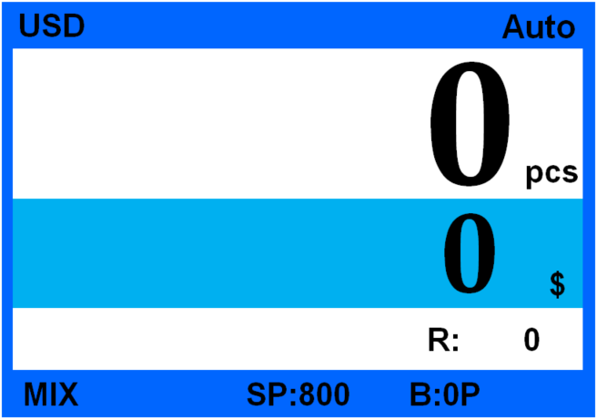
Figure 20

6.6 Accumulation Function
Press “6 ADD” key under any kind of counting mode to turn on accumulation function. The Figure 21 shows the Accumulation function is turned on.
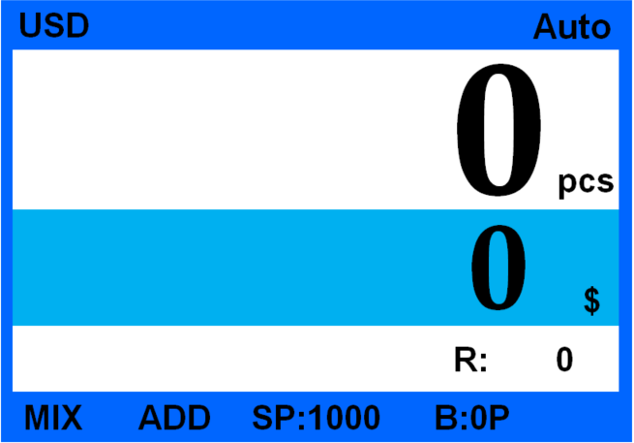
Figure 21

7. Check counting result and printing information

7.1 Check counting result
Under MIX mode or SDC mode, after counting, press “4 LIST” key to check the counting details as shown by Figure 22 :
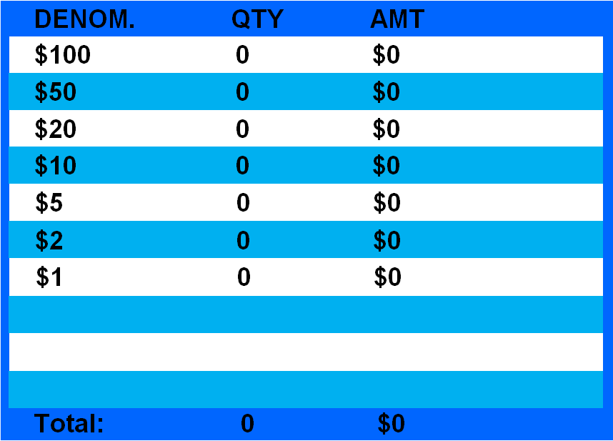
Figure 22
This interface is for checking the quantity and amount for each denomination you counted, as well as the total amount.

7.2 Check Suspected Notes Details and Serial Number
7.2.1 Check Suspected Notes Details
After finish counting, if there are suspected notes in reject pocket and want to check reject reason, please press “5 REJECT/SN.” key to enter into following interface(Figure 16) to check detailed information. To exit from current interface you can press ESC key or put notes on hopper to count directly.
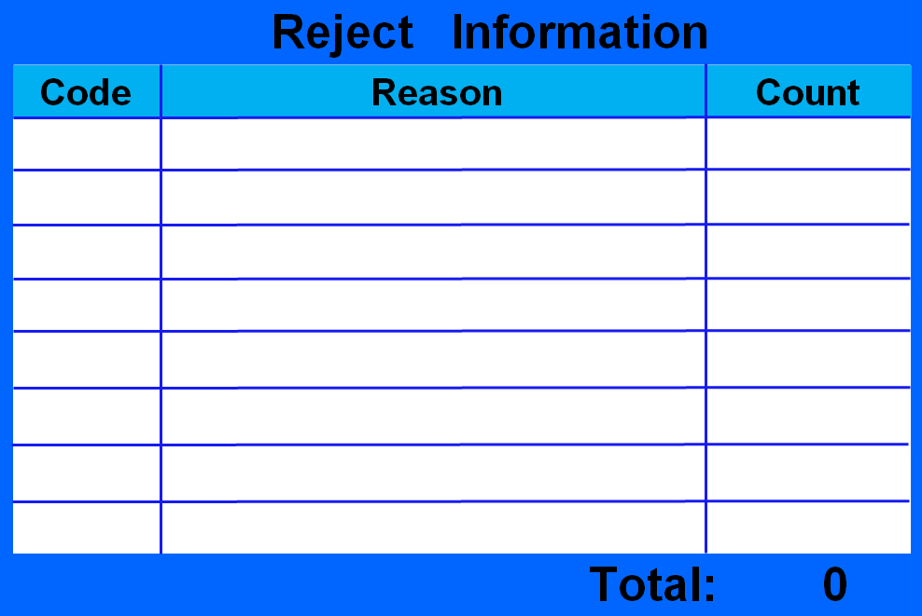
Figure 23
Error Codes List
No | Error code | Explanations
R-01 | Stacker Full | The stacker is full
R-02 | MG Quantity | Side MG quantity is not correct
R-03 | MG Position | Side MG position is not correct
R-04 | MT Quantity | Middle MG quantity is not correct
R-05 | MT Code | Middle MG code is not correct
R-06 | UV | UV mark is abnormal
R-07 | Double | Double note is detected
R-08 | Half | Half note is detected
R-09 | Long | Banknote image is too long
R-10 | Short | Banknote image is too short
R-11 | Gap | Chain notes are detected
R-12 | IMG Timeout | Image processing is timed out
R-13 | IMG Size Unknow | Image size is unknown
R-14 | IMG ORT Unknow | Image orientation is unknown
R-15 | IMG Version | Image version is not correct
R-16 | IMG FACE | Face image is not correct
R-17 | IMG ORT | Orientation image is not correct
R-18 | IMG Angle | Image angle is not correct
R-19 | IR OVD | OVD image is not correct
R-20 | IR MT | IR metal thread is abnormal
R-21 | IR Hole | Hole is detected
R-22 | IR Dog-Ear | Dog-ear image is detected
R-23 | IMGDIRT | Dirty image is detected
R-24 | IRFeature1 | IR feature 1 is detected
R-25 | IRFeature2 | IR feature 2 is detected
R-26 | IRFeature3 | IR feature 3 is detected
R-27 | IRFeature4 | IR feature 4 is detected
R-28 | IRFeature5 | IR feature 5 is detected
R-29 | IRFeature6 | IR feature 6 is detected
R-30 | IRFeature7 | IR feature 7 is detected
R-31 | IRFeature8 | IR feature 8 is detected
R-32 | IMG FACE ORT | Image face and orientation is abnormal
R-34 | OCR1 | Serial number is coved
R-35 | OCR2 | Serial number is wrong

7.2.2 Check Serial Number
Under the interface of Figure 15 press “5 REJECT/SN.” key to enter into following interface as shown by Figure 24 to check serial number:
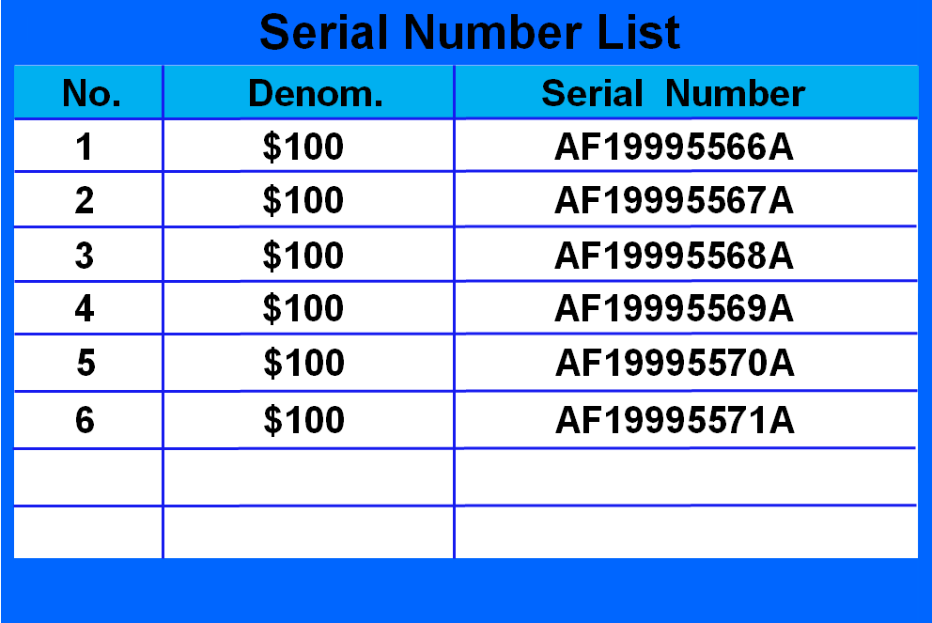
Figure 24
Under this interface you can read and check the serial number of accepted notes, press arrow key to turn pages. To exit the interface please press ESC key or put the notes to count directly.
Notes: this interface can only show when serial number reading function is turned on(SP:800).

7.3 Printing Information
When external printer is connected and is ready for printing, after counting, press LIST key to enter into list checking interface, then press “7 PRINT” key the printer will print the counting list and total amount automatically. Under the interface of serial number reading, press PRINT key to print the serial number.

8. User Setting
Press “8 SET” key to enter into User Setting interface as Figure 25 shows.
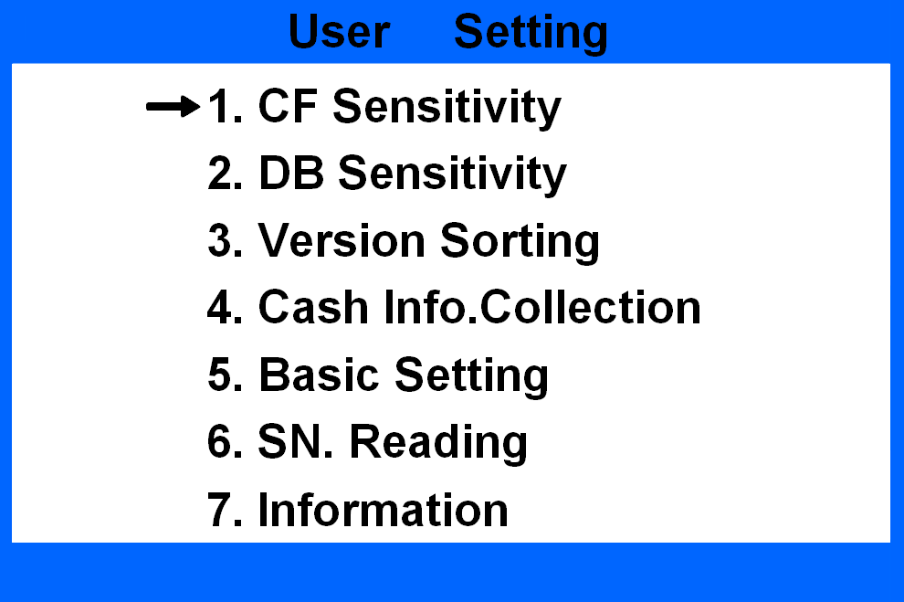
Figure 25
Press the cursor to select and press ENTER to enter into next menu, press ESC to return to last menu.

8.1 Counterfeit Detection Setting
Under Figure 25 interface, move the cursor to No.1 CF Sensitivity, press ENTER key to enter into Figure 26 interface:
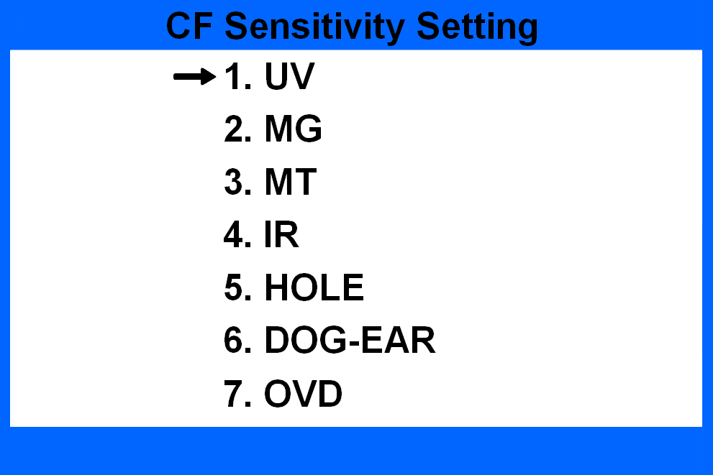
Figure 26
The detailed explanation for each function for Figure 19 is as below:
NO. | Fuc.Setting | Explanation
1 | UV | UV detection level setting
2 | MG | side MG detection level setting
3 | MT | MT detection level setting
4 | IR | IR detection level setting
5 | HOLE | Hole detection level setting
6 | DOG-EAR | folded corner detection level setting
7 | OVD | Optical variable strip detection setting
Choose the function you want to set and press ENTER key to enter, press ESC key to return to last menu.

8.1.1 UV Detection Setting
Under Figure 26 interface, choose No.1 UV and press ENTER key to enter interface as Figure 27 shows:
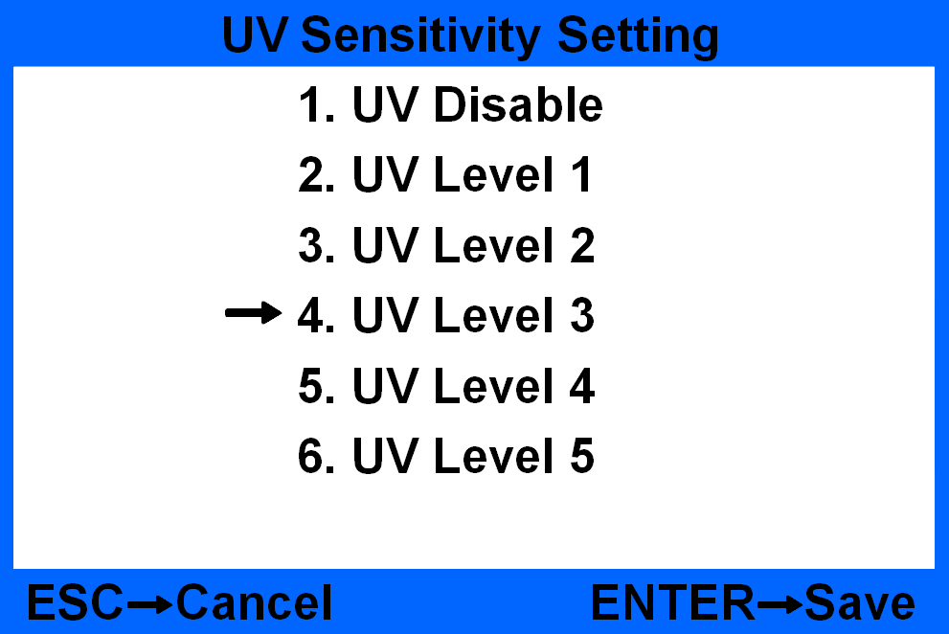
Figure 27
Under this interface there are 5 different levels for selection and 1 option to disable the detection. The higher the level the more sensitive it is. After choose the proper level press ENTER key to save setting, the default setting is Level 3.

8.1.2 MG Detection Setting
Under Figure 26 interface choose No.2 MG and press ENTER key to enter interface as Figure 28 shows.
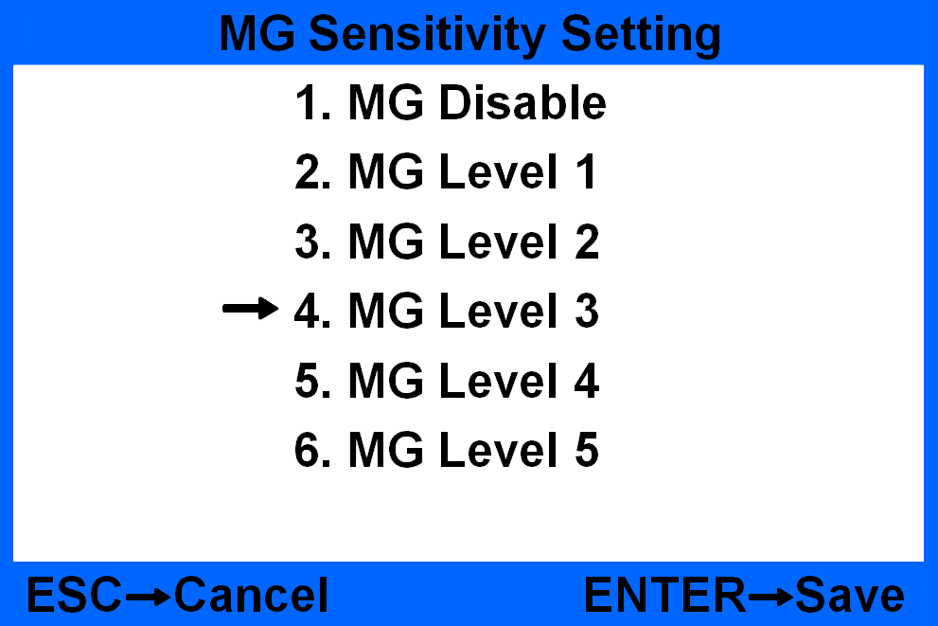
Figure 28
Under this interface there are 5 different levels for selection and 1 option to disable the detection. The higher the level the more sensitive it is. After choose the proper level press ENTER key to save setting, the default setting is Level 3.

8.1.3 MT Counterfeit Detection Setting
Under interface Figure 26 to choose No. 3 MT and press ENTER key to enter interface as Figure 29 shows.
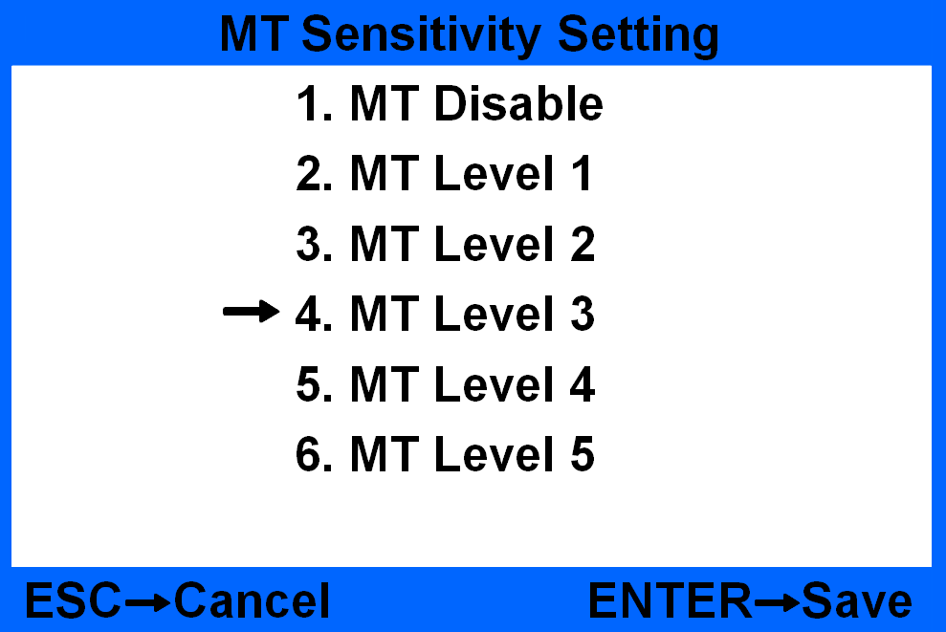
Figure 29
Under this interface there are 5 different levels for selection and 1 option to disable the detection. The higher the level the more sensitive it is. After choose the proper level press ENTER key to save setting, the default setting is Level 3.

8.1.4 IR Counterfeit Detection Setting
Under interface Figure 26 to choose No.4 IR, press ENTER key to enter interface as Figure 30 shows.
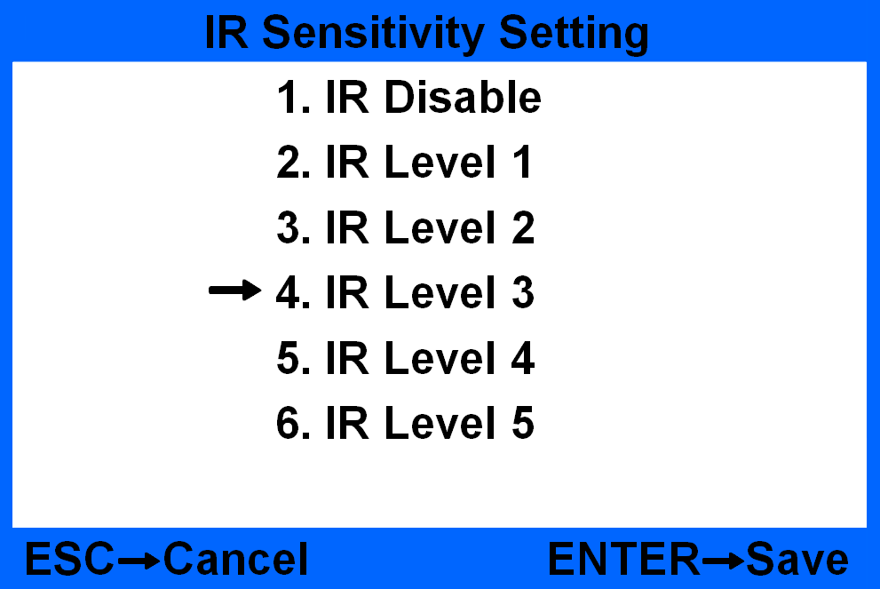
Figure 30
Under this interface there are 5 different levels for selection and 1 option to disable the detection. The higher the level the more sensitive it is. After choose the proper level press ENTER key to save setting, the default setting is Level 3.

8.1.5 Hole detection level setting
Under Figure 26 interface choose No.6 Hole and press ENTER key to enter into Figure 31 interface.
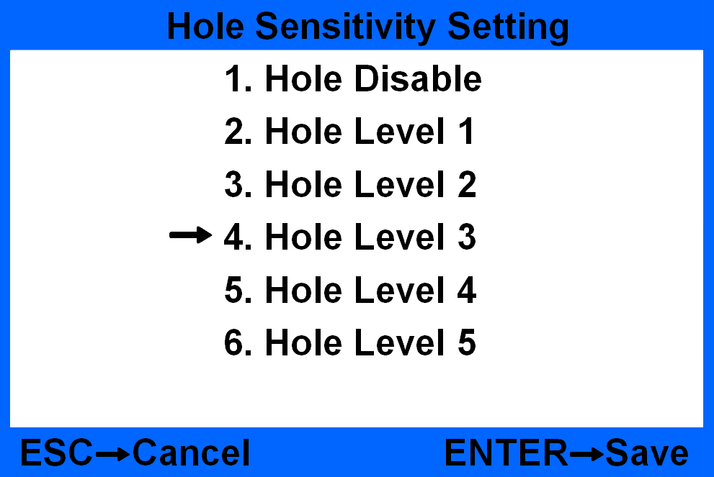
Figure 31
Under this interface there are 5 selectable choices and 1 Off choice, the higher the level the more sensitivity it is. After choose the suitable level please press ENTER key to save, the default setting is level 3.

8.1.6 Dog-Ear detection level setting
Under Figure 26 interface please choose No.7 Dog-Ear and press ENTER to enter into Figure 32 interface.
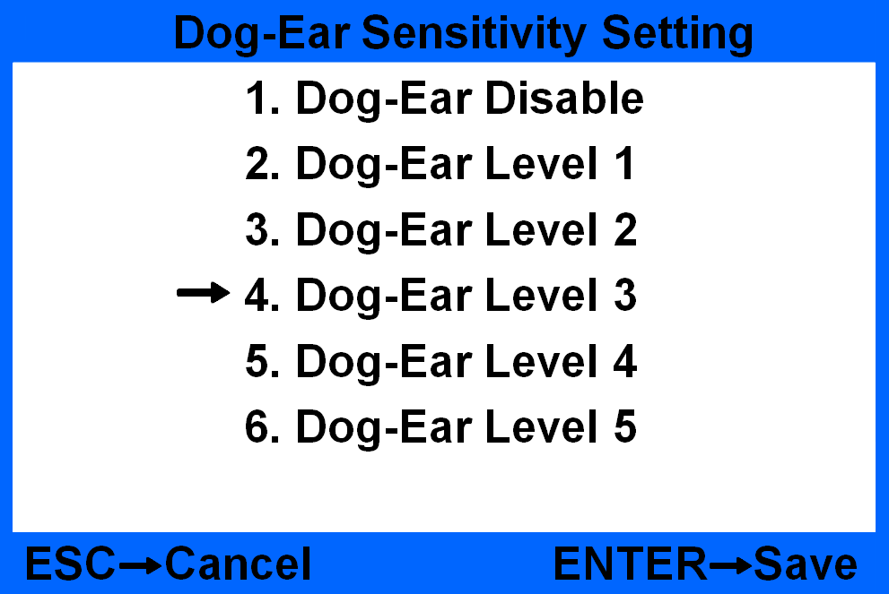
Figure 32
Under this interface there are 5 selectable choices and 1 Off choice, the higher the level the more sensitivity it is. After choose the suitable level please press ENTER key to save, the default setting is level 3.

8.1.7 OVD detection level setting
Under Figure 26 interface please choose No.8 OVD and press ENTER to enter into Figure 33 interface.
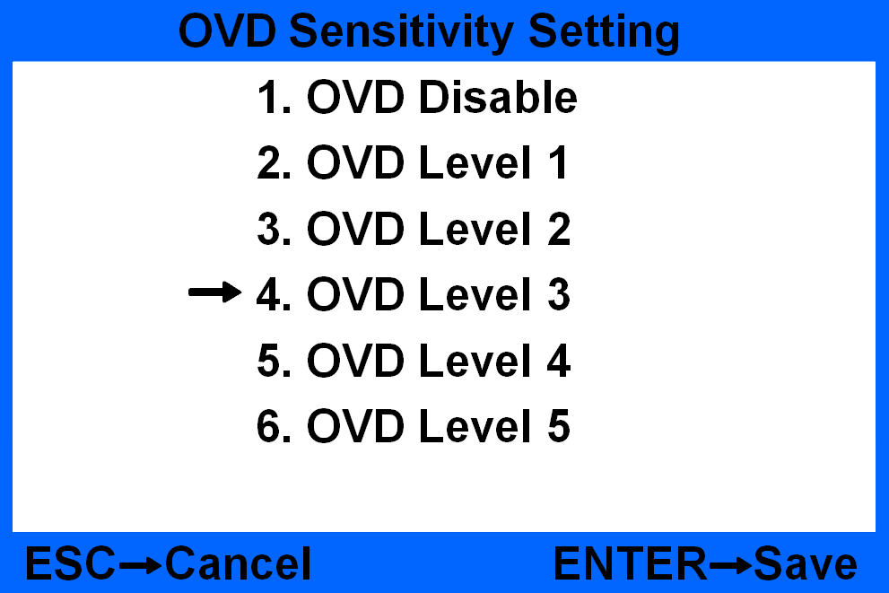
Figure 33
Under this interface there are 5 selectable choices and 1 Off choice, the higher the level the more sensitivity it is. After choose the suitable level please press ENTER key to save, the default setting is level 3.

8.2 Double banknotes detection setting
Move the cursor to the user setting interface under Figure 25, choose item 2 DB sensitivity and then press ENTER key to come into the following Figure 34 interface:
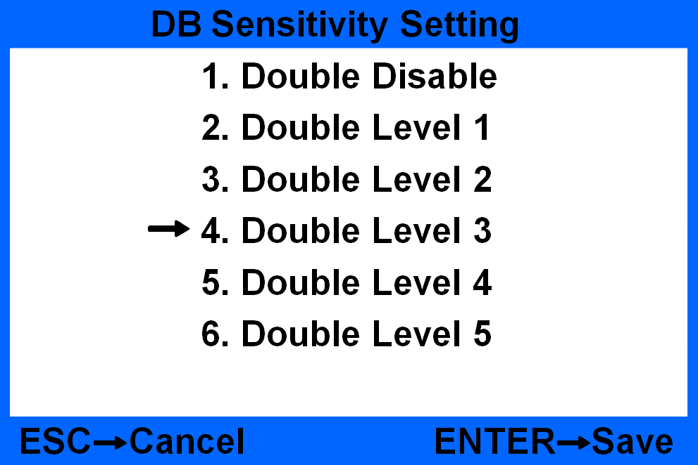
Figure 34
Press “” or “” key to choose different sensitivity level or disable DB detecting function. The higher the level, the more sensitive the detection is. After setting, press ENTER key to save. Press ESC key will quit to the previous menu. The default setting is level 3.

8.3 Banknote version sorting setting
Move the cursor to the user setting interface under Figure 25, choose item 3. Version sorting and then press ENTER key to enter the below interface, shown as Figure 35:
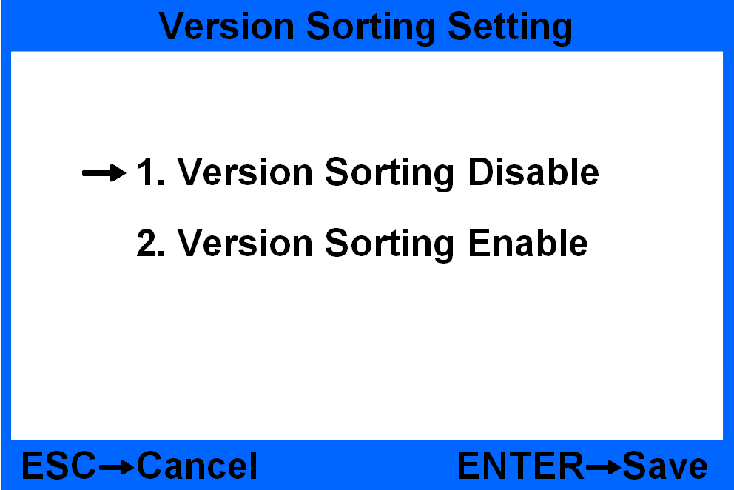
Figure 35
Press “” or “” key to disable or enable the version sorting function and then press ENTER key to confirm. Press ESC key will quit to the previous menu.
When the function is enabled, there will be a sign of V displayed on the screen, shown as Figure 36. For the same version banknotes, they will be counted to stacker; for those different version banknotes, they will be rejected to the reject pocket. This function is only valid for SDC mode.
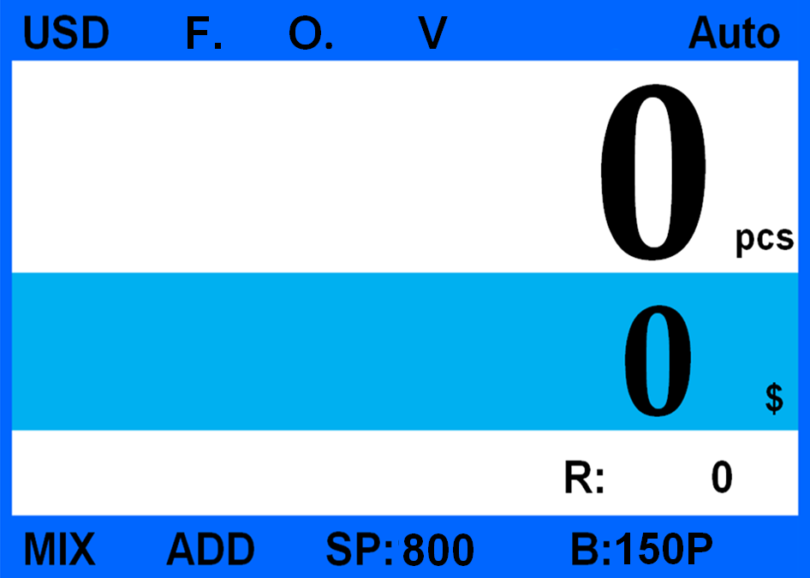
Figure 36

8.4 Banknote information collection
Move the cursor to the user setting interface under Figure 25, choose item 4. Cash info. collection and then press ENTER key to enter the below interface, shown as Figure 37:
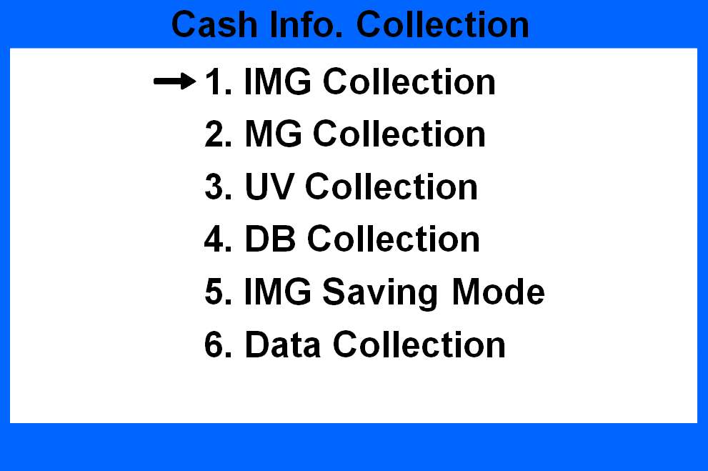
Figure 37
Press “” or “” key to choose different information collection and then press ENTER key to confirm. Press ESC key will quit to the previous menu.

8.4.1 Image information collection
Under Figure 30 interface to choose item 1. IMG Collection and then press ENTER key to come into the following setting interface, shown as Figure 31:
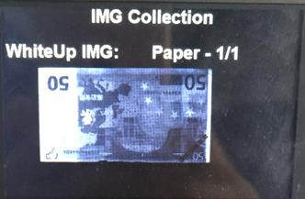
Figure 38 Figure 39
Put one banknote to count, the display will show its image on the screen, shown as Figure 32. By pressing “” or “” key to turn on the pages, you will get total five different images.
This image collection function is only valid under MIX and SDC modes.

8.4.2 UV/MG/DB information collection
Under Figure 37 interface to choose item 2 to 4, and then press ENTER key to enter, you could collect the banknote’s MG/UV/DB information.
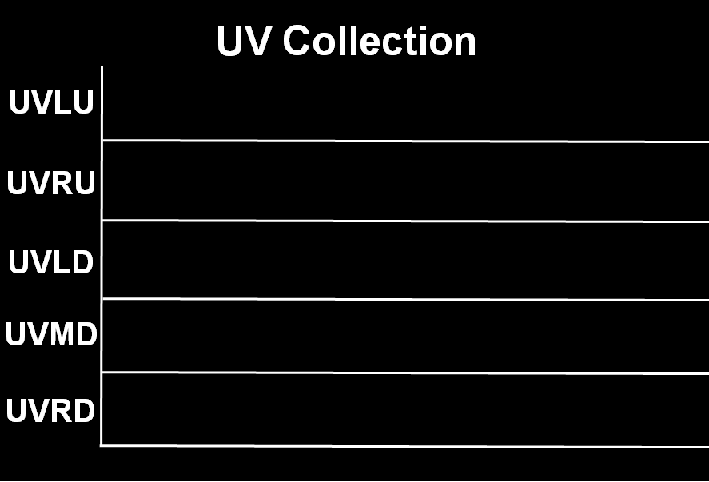
Figure 40

8.4.3 Image saving setting
*Notes: Before you collect the images, please make sure the USB flash drive is well inserted. There will be a sign of “U” on the bottom right screen corner if the drive is successfully connected, shown as Figure 41.
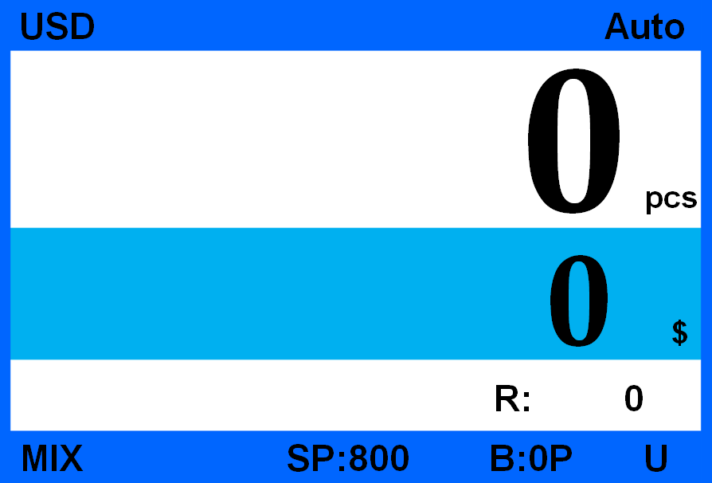
Figure 41
Under Figure 37 interface to choose item 5. IMG saving mode and then press ENTER key to come into the following interface, shown as Figure 42:
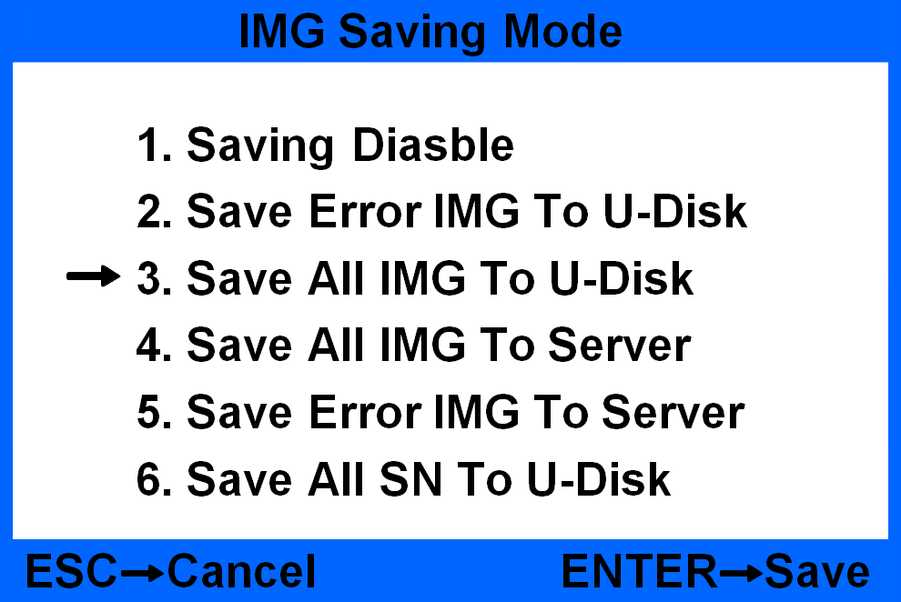
Figure 42
Press “” or “” key to choose different mode and then press ENTER to save.
The default setting is saving disable. Item 2 is only to save error images for those rejected banknotes from the reject pocket to USB flash drive. Item 3 is to save all images for all counted banknotes from both reject pocket and stacker to USB flash drive. After image saving, it will create automatically files named IMGERR(for error images only) and IMGALL(for all images), all images will be saved to the file according to date.
Below Figure 36 shows the process of image saving.
Figure 43
8.4.4 Data collection
Under Figure 37 interface to choose item 6. Data collection and press ENTER key to come into the following interface Figure 44:
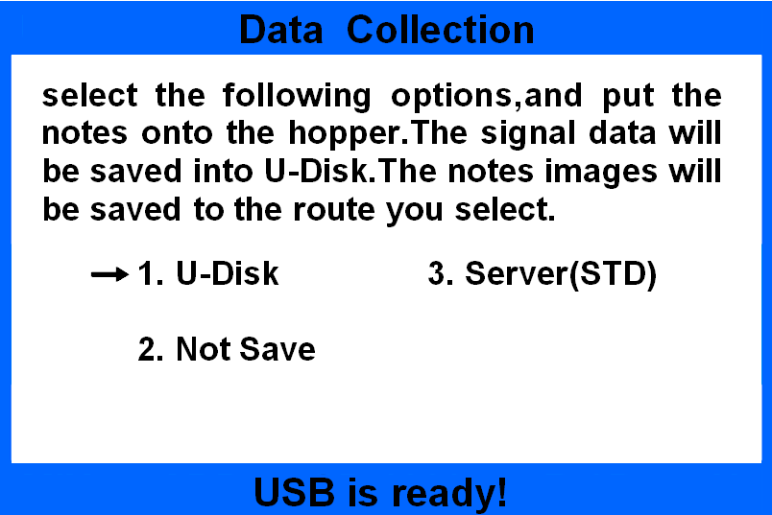
Figure 44
Before you collect data, please make sure the USB flash drive is successfully connected. Load one batch banknotes to count, the machine will collect banknote data(image, UV, MG, DB) for every 10pcs. After collection, it will save images to a created file named CASHINFO, all images will be saved to this file according to date.
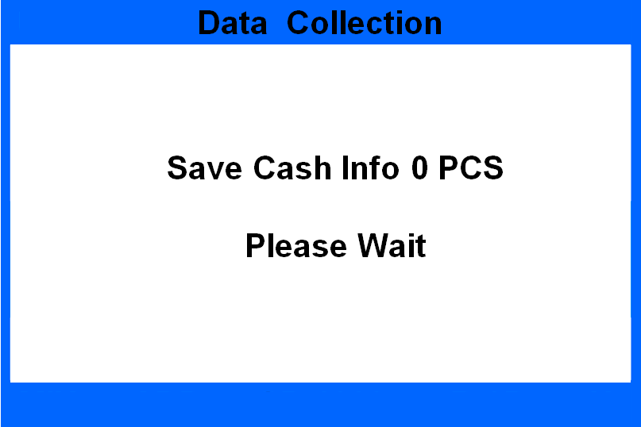
Figure 45
*Notes: During the data saving process, it need some time to finish, please wait with patience.

8.5 Basic setting
Move the cursor to the user setting interface under Figure 25, choose item 5. Basic setting and then press ENTER key to enter the below interface, shown as Figure 46:
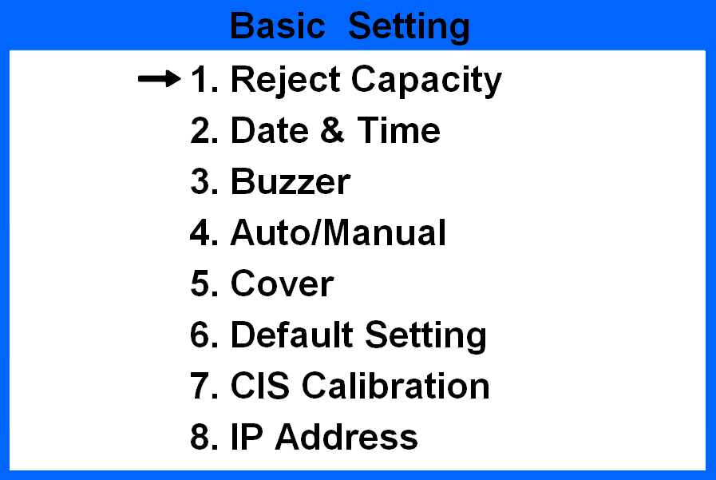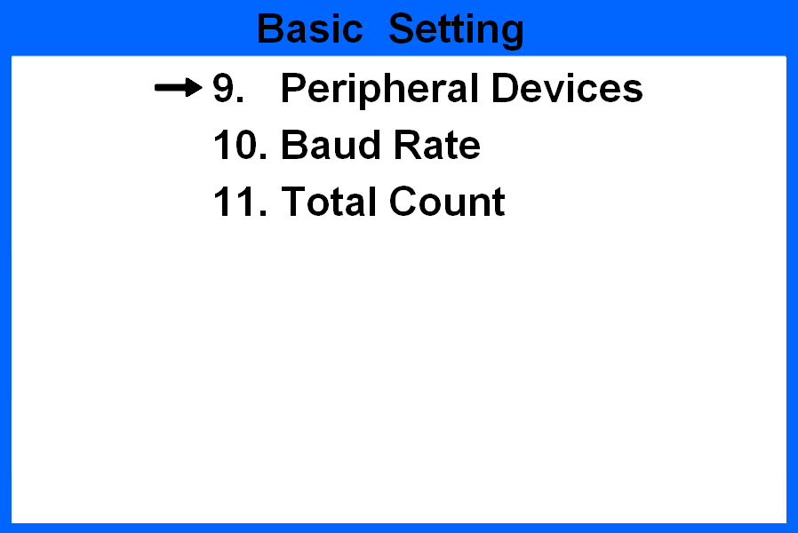
Figure 46
Under this interface, you could set reject pocket capacity, date and time, buzzer, machine start way, dust-proof cover, default setting, calibration and IP address.

8.5.1 Reject pocket capacity setting
Under Figure 46 interface to choose item 1. Reject Capacity and then press ENTER key to come into the following setting interface, shown as Figure 47:
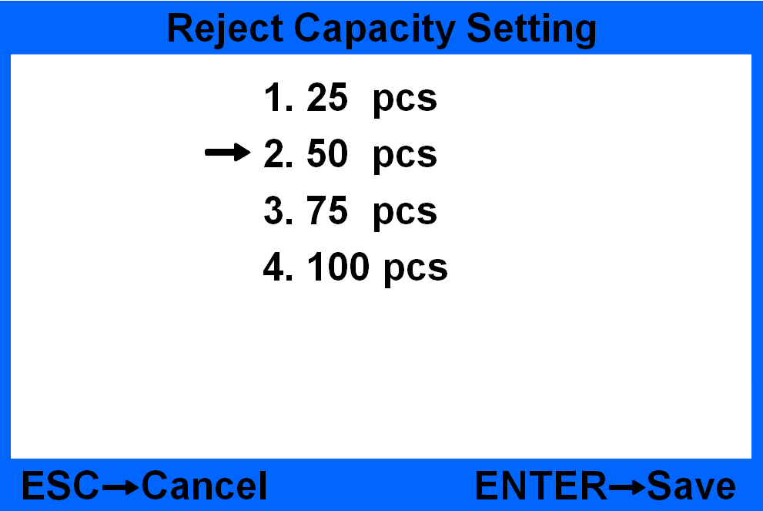
Figure 47
By pressing “” or “” key to choose different quantity and then press ENTER key to save. The default setting is 50pcs.
8.5.2 Date & time setting
Under Figure 46 interface to choose item 2. Time & Date and then press ENTER key to come into the following setting interface, shown as Figure 48:
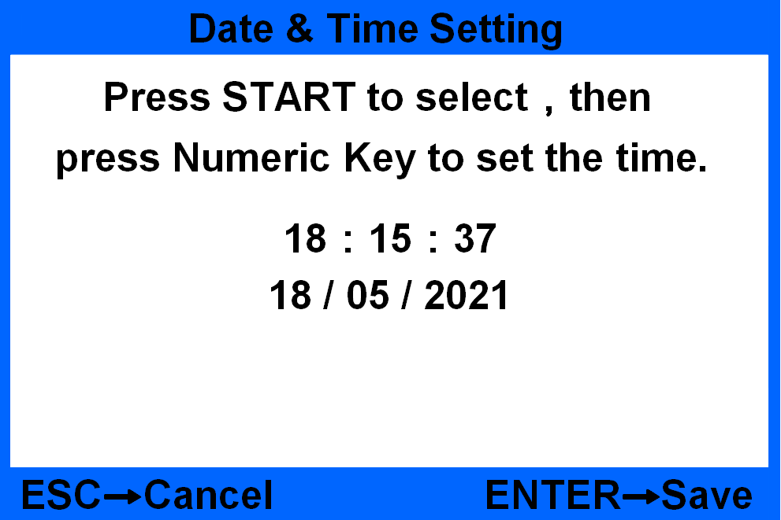
Figure 48
After setting, press ENTER key to save. Press ESC will quit from the interface.

8.5.3 Buzzer setting
Under Figure 46 interface to choose item 3. Buzzer and then press ENTER key to come into the following setting interface, shown as Figure 49:
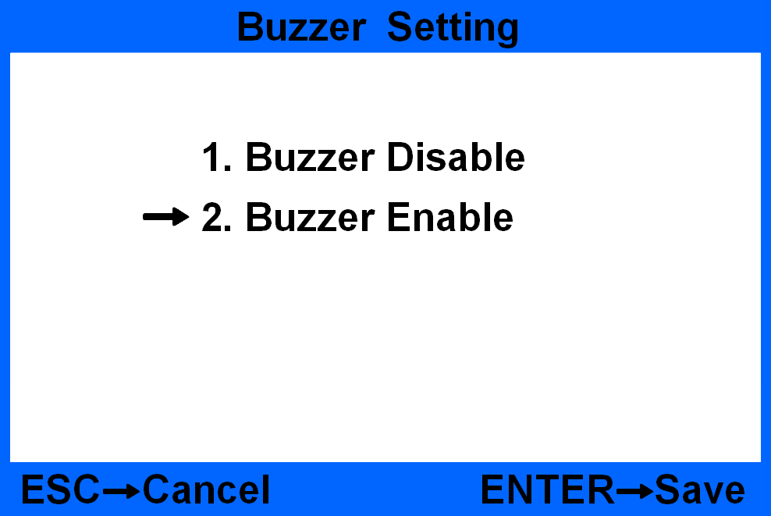
Figure 49
By pressing “” or “” key to set the buzzer function ON/OFF, then press ENTER key to save. Press ESC will quit from the interface. The default setting is buzzer enable.

8.5.4 Start way setting
Under Figure 46 interface to choose item 4. Auto/Manual and then press ENTER key to come into the following setting interface, shown as Figure 50:
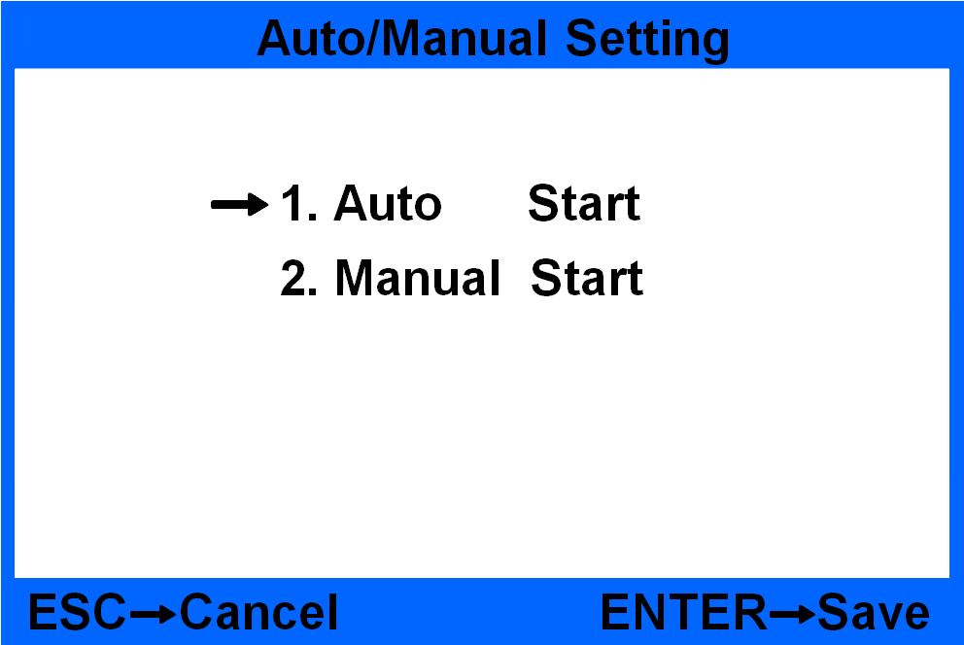
Figure 50
Press “” or “” key to choose automatic machine start or manual machine start. After setting, press ENTER key to save. Press ESC will quit from the interface. The default setting is auto start.

8.5.5 Dust proof cover setting
Under Figure 46 interface to choose item 5. Cover and then press ENTER key to come into the following setting interface, shown as Figure 51:
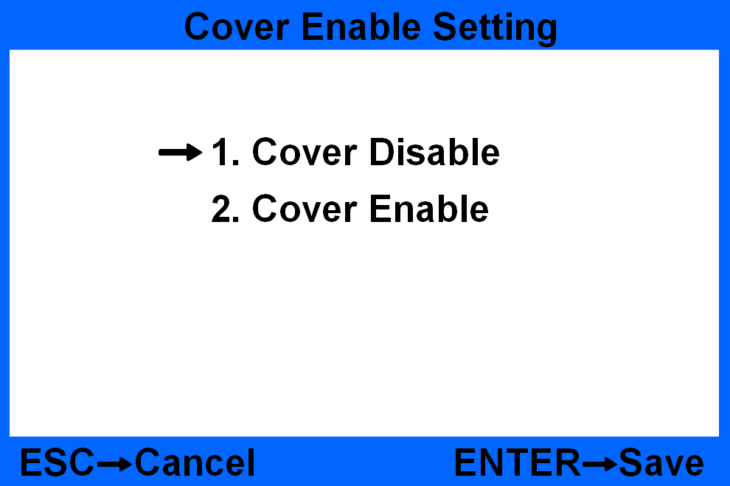
Figure 51
Press “” or “” key to choose cover ON/OFF. After setting, press ENTER key to save. Press ESC will quit from the interface .The default setting is cover disable.

8.5.6 Default setting
Under Figure 46 interface to choose item 6. Default setting and press ENTER key to confirm. After inputting the passwords 1234, it will come into the following interface, shown as Figure 52:
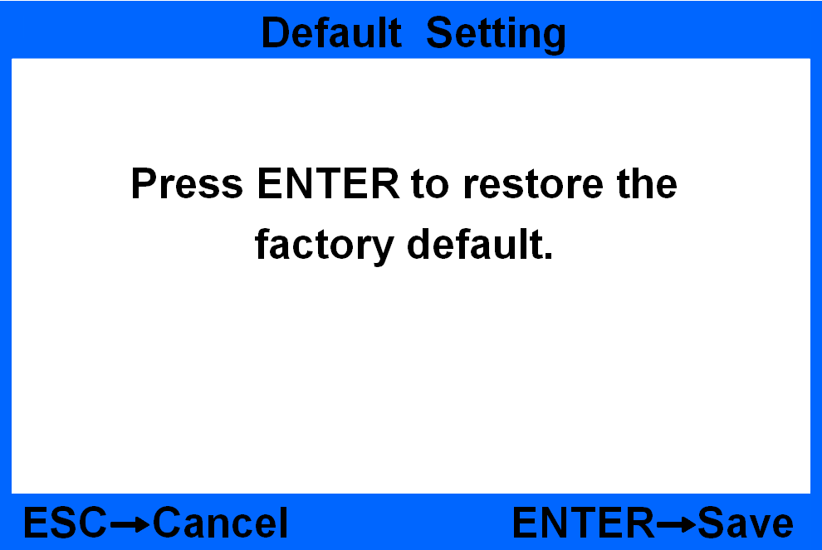
Figure 52
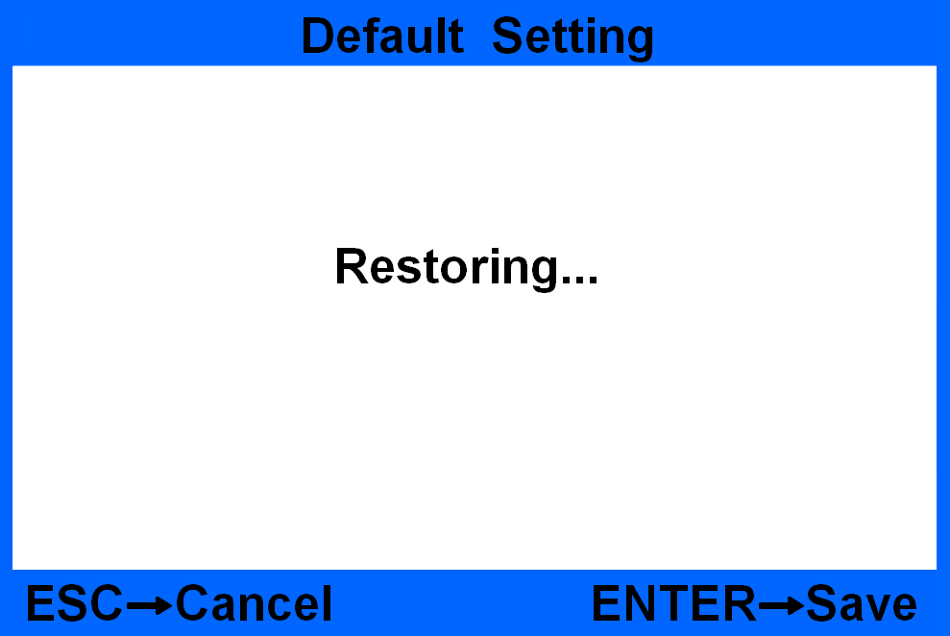
Figure 53
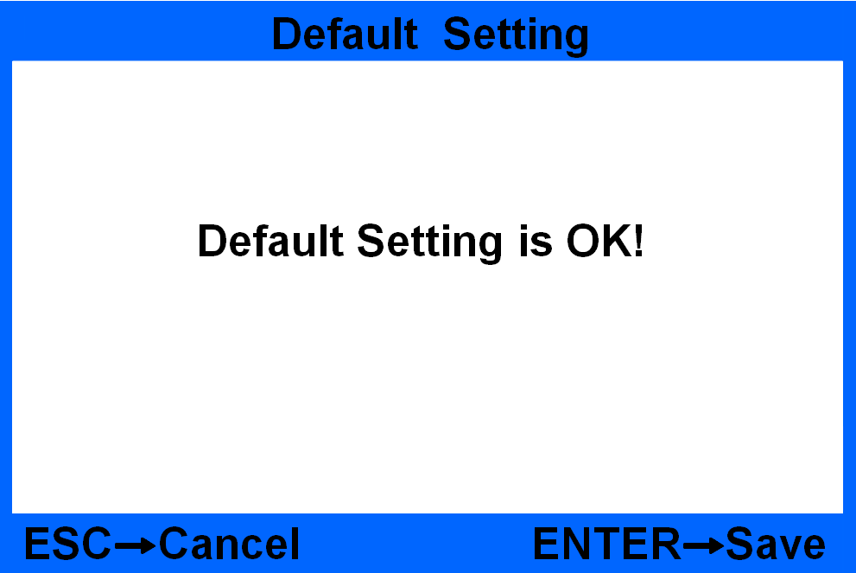
Figure 54
By following the indicative message on the screen, press ENTER key to confirm. After restoring successfully, it will display the messages “Default setting is OK!”, shown as Figure 54.

8.5.7 CIS calibration
Under Figure 46 interface to choose item 7. CIS calibration and press ENTER key to confirm. After inputting the passwords 0508, it will come into the following interface, shown as Figure 55:
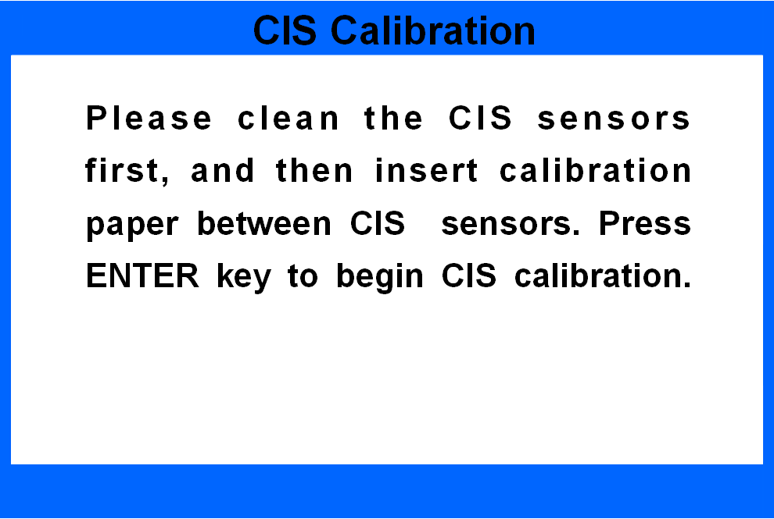
Figure 55
Before you begin the CIS calibration, please make sure you have inserted the calibration paper correctly, otherwise it will cause problem. The calibration paper must cover the whole CIS sensor.

8.5.8 IP address setting
Under Figure 46 interface to choose item 8. IP setting and then press ENTER key to come into the following interface and then set the IP address by pressing the numeric keys:
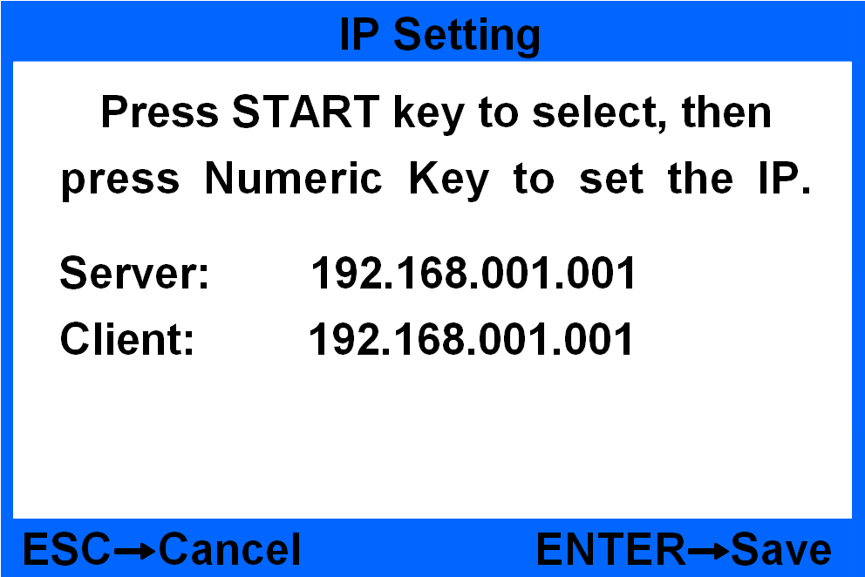
Figure 56

8.5.9 Port Setup
Move the cursor to Figure 46 choose No.9 and press ENTER to enter into Peripheral Devices Setting as below picture, you can choose to connect with Printer or PC through RS232 port
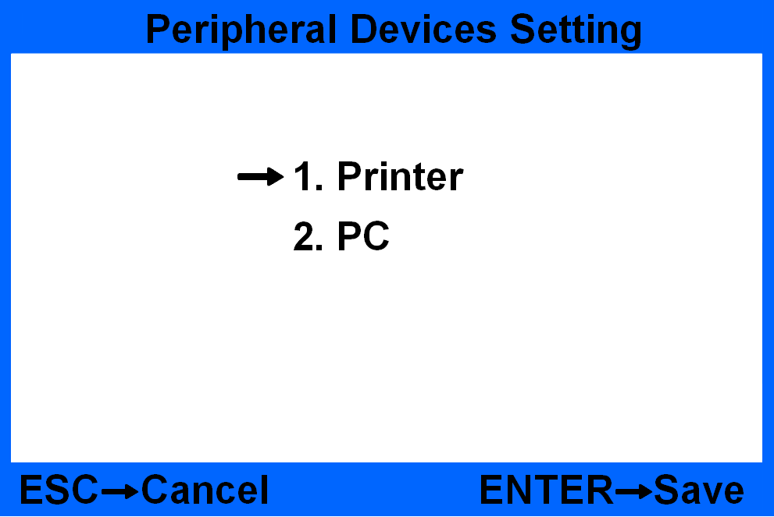
Figure 57
8.5.10 Baud Rate Setting
Move the cursor to Figure 46 choose No.10 and press ENTER to enter into Baud Rate Setting as below picture, you can choose the baud rate according the external devices’ baud rate.
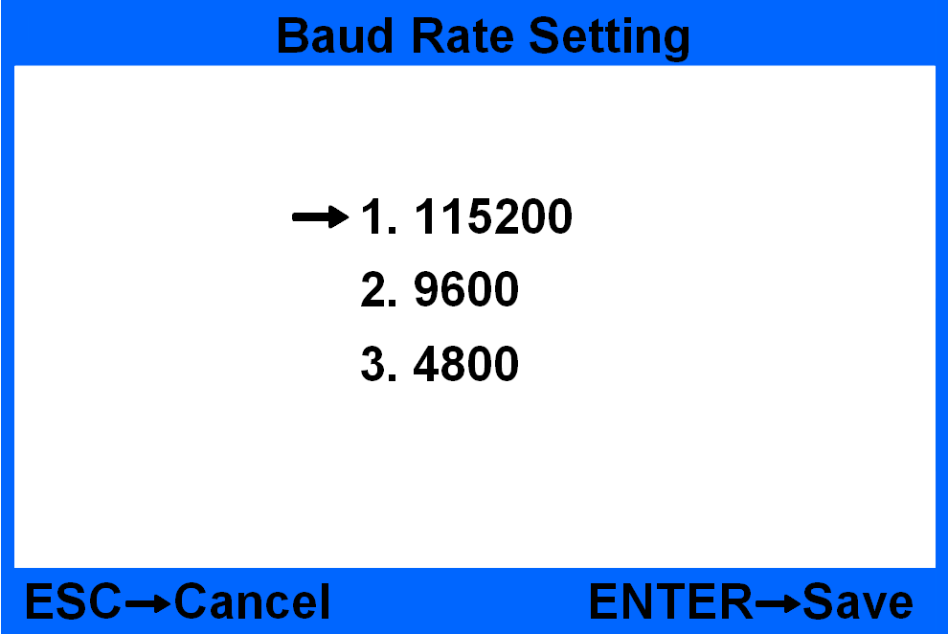
Figure 58
8.5.11 Other functions
Prefix/serial number switch function setting interface：
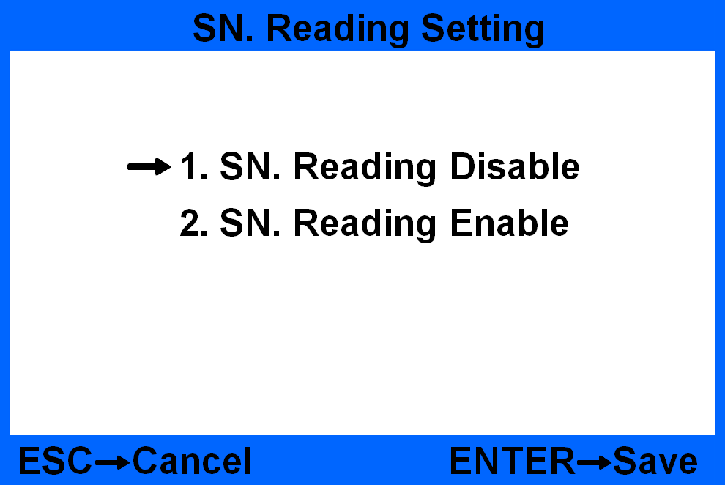
Figure 59
Software version view interface：
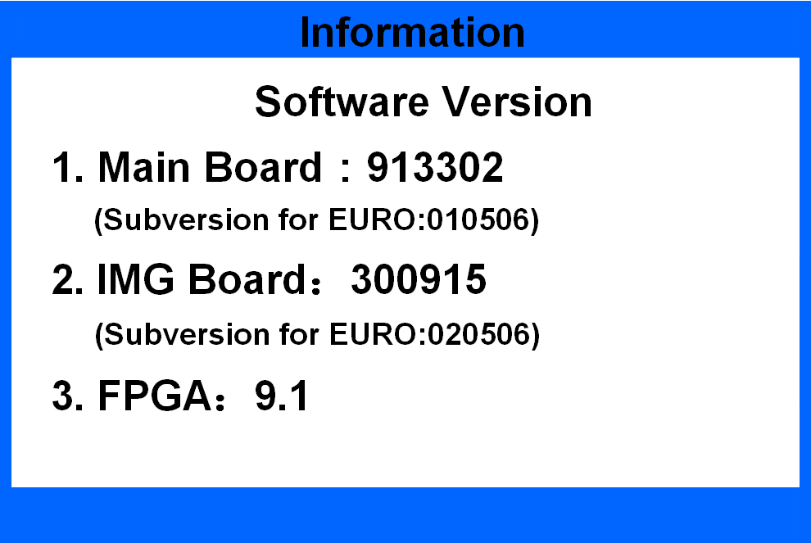
Figure 60

8.6 Sensitivity Setting for QT sensor
Turn on the power switch and press “8 SET” key to enter into SYSTEM TEST interface.
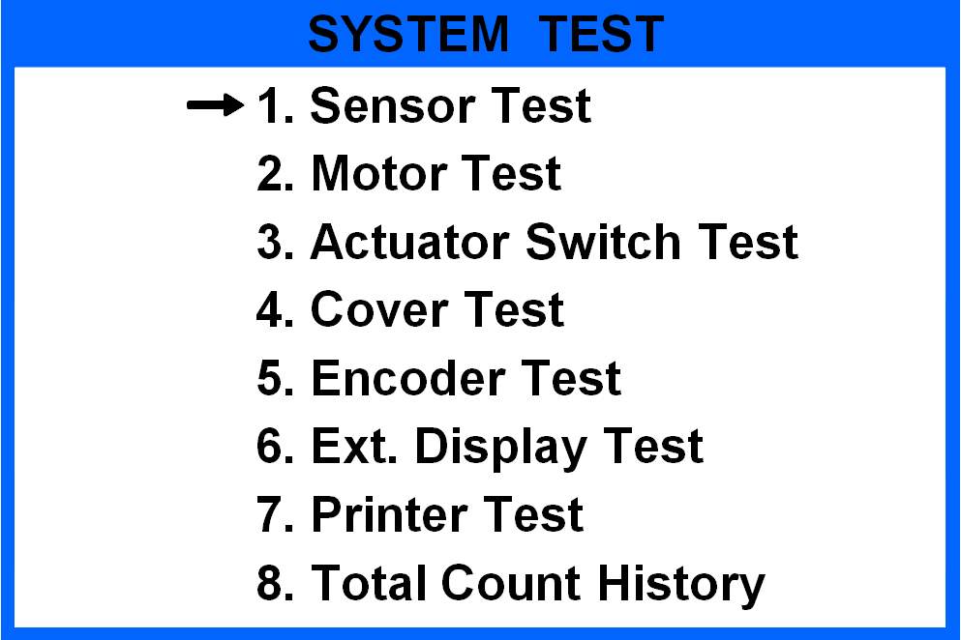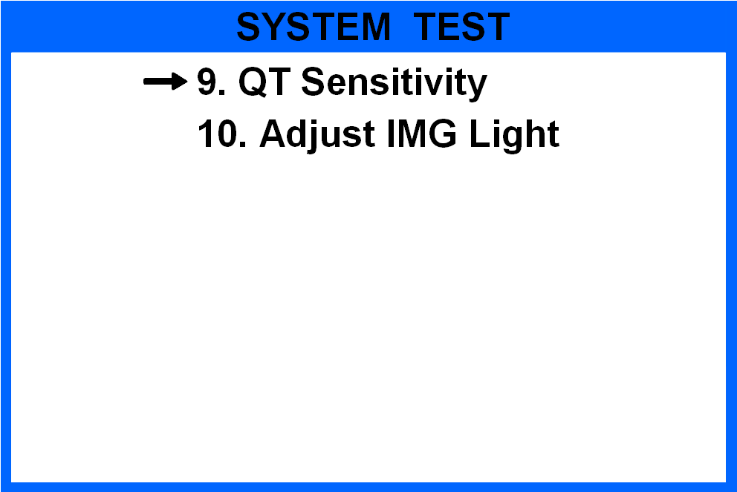
Figure 61
Choose No.9 and press ENTER to enter into QT sensitivity level setting interface. The factory default setting is level 3, means highest sensitivity. Level 1 means lowest sensitivity. Press ENTER key to save and exit level setting interface
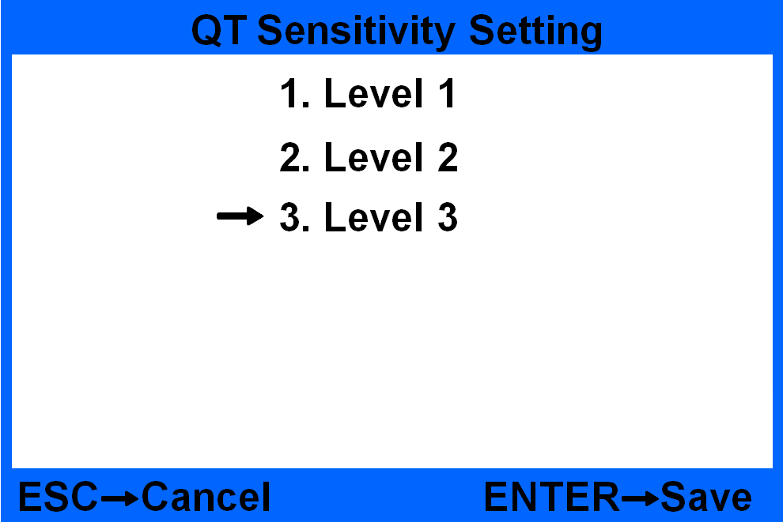
Figure 62

9. Troubleshooting

9.1 Common errors
During use of machine, sometimes you may meet some abnormal situation and the machine cannot work normally, and the machine will display error messages. The following sheet shows the error message, possible reason and detailed solution. Please do trouble shooting according to the following solution. If you can not solve the problem with the provided solution, please contact your local distributor.
Figure 63
Figure 64

9.2 Banknote jamming and solution
If the notes get jammed during counting progress, there will be warning messages displayed on the screen. You need to take out the jammed notes firstly and then press START key to check if there is still hidden jammed notes. Last, press CLEAR key to clear warning message. If the machine still displays “JAM”, you will need to open the machine and take out the notes from interior passage.
Once jamming happens, please recount the notes to avoid counting mistake.
*After clean the sensor and passagewell, please press “CLEAR” key to clear the error interface and enter into main interface to go on counting.
*If after checking, there is no foreign items blocking the sensor, and after press “CLEAR” key there is still error interface, please refer to service manual to do trouble shooting.

10. Software Upgrade
This model adopts flash drive (USB) upgrading method for software upgrade. Please copy the upgrading file into the flash drive, and insert the flash drive into the USB port at the back of machine. Hold on pressing the START key, and then turn on the power switch, you will find the choosing interface as follows:
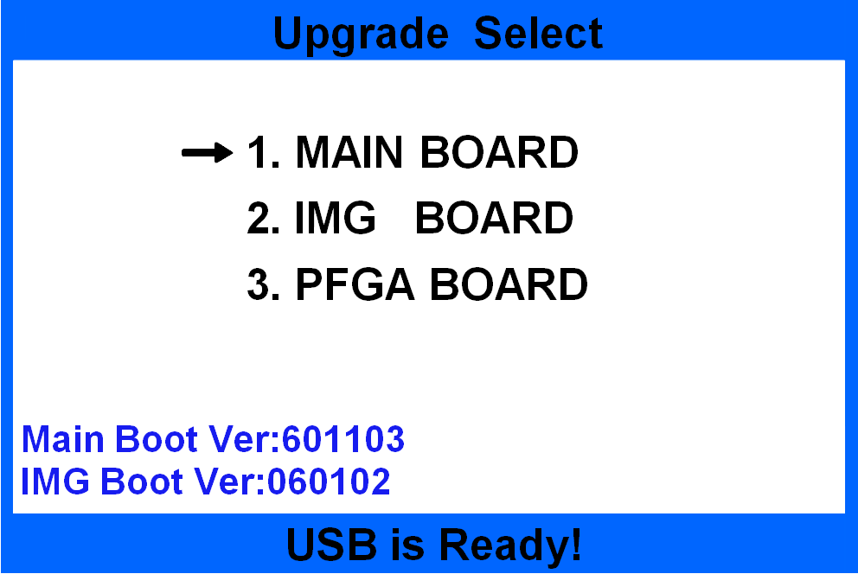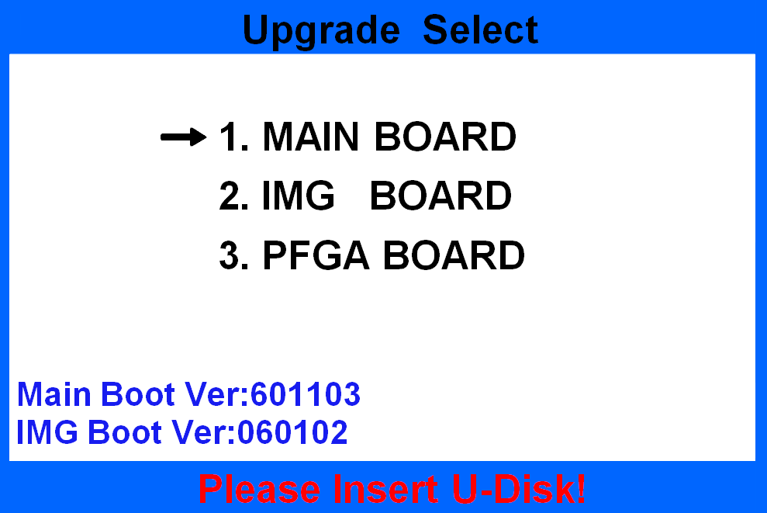
Figure 65 Figure 66
*If the USB flash drive is inserted well, the display will show “USB is Ready!”, otherwise it will show “Please insert the U-Disk!”.
For the upgrading file, it is not allowed to change its name and format, otherwise will cause upgrade failure.

10.1 MAINBOARD upgrading
Under interface Figure 65, press “” or “” key to choose “1.MAINBOARD”, and then press ENTER key to start software upgrading, shown as Figure 67. If there is no software file or file name is not correct, it will display warning messages shown as Figure 68.
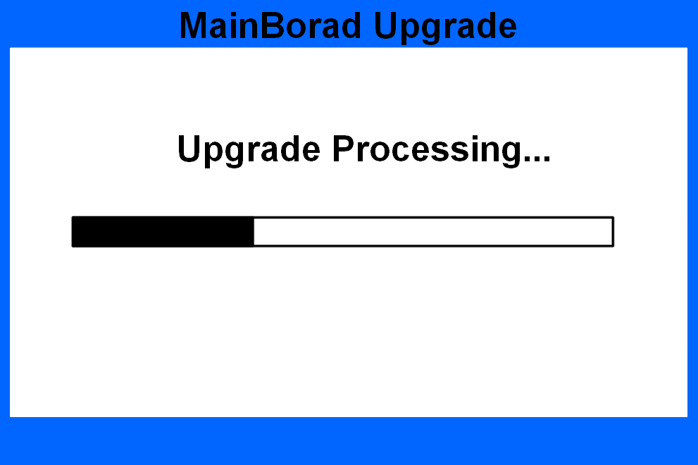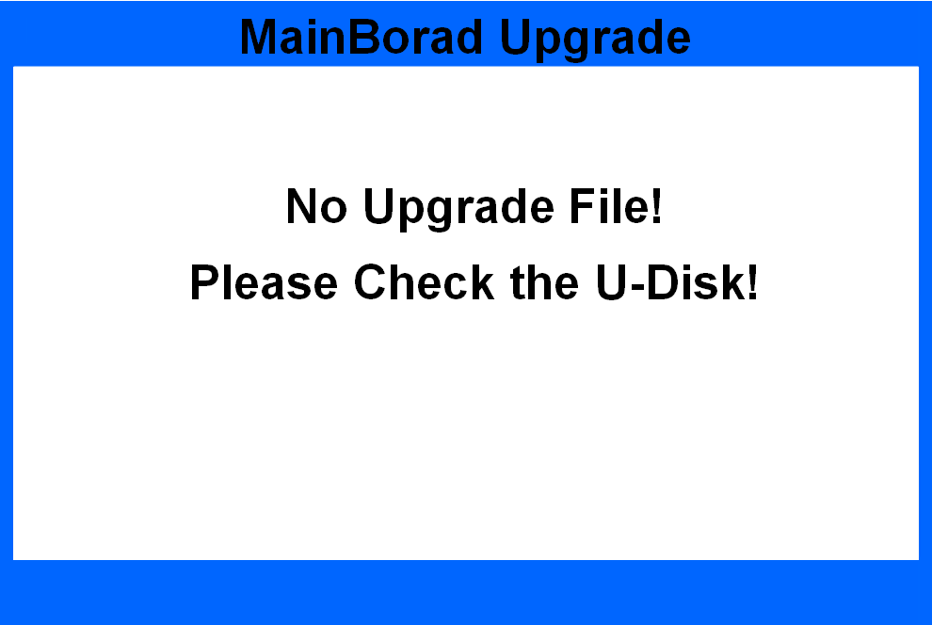
Figure 67 Figure 68
After software upgrade, please restart the machine referring to the following message.
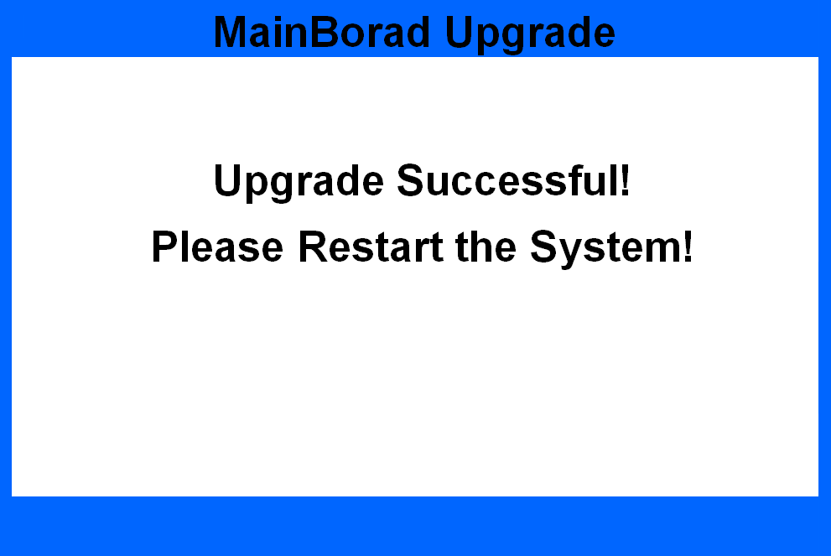
Figure 69

10.2 IMAGEBOARD upgrading
Under interface Figure 65, press “” or “” key to choose “2. IMG BOARD” and then press ENTER to start software upgrading, shown as Figure 70 and Figure 71. If there is no software file or file name is not correct, it will display warning messages shown as Figure 68.
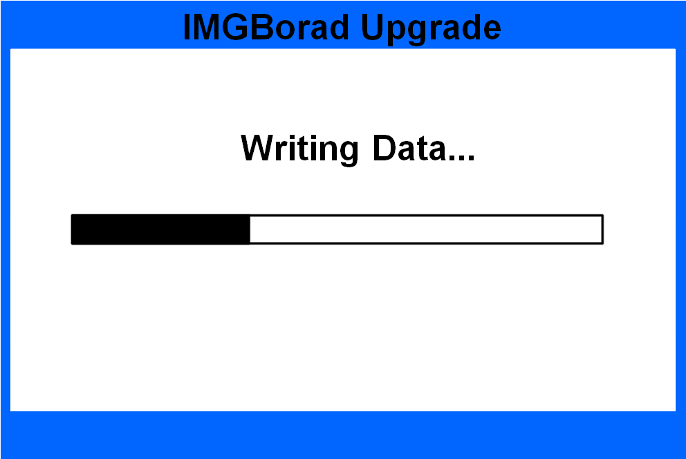
Figure 70 Figure 71
After software upgrade, please restart the machine referring to the following message.
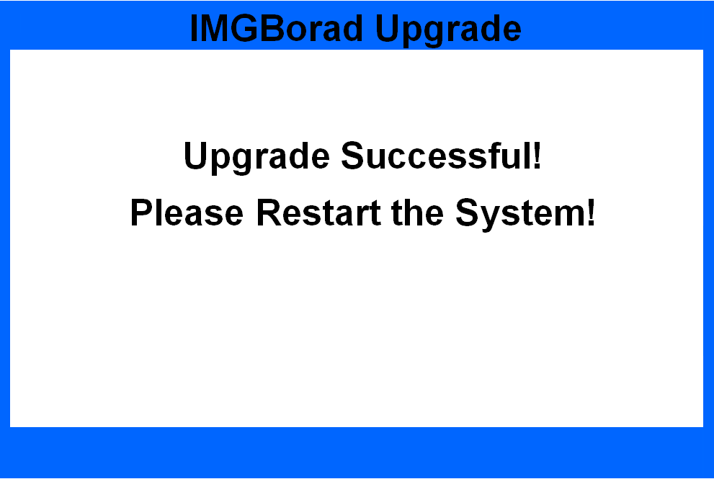
Figure 72

11. Image Collection through PC

11.1 Configure the IP address of PC
Decompress the PC image acquisition software "serverforbcs160_v7.0. Rar" provided by our company to obtain a folder named "serverforbcs160_v7.0". This software can only run under the system above Windows system, You also need to install ". Net4.0" software. Please check whether the file path "C: \ windows \ Microsoft. Net \ framework" of PC side C disk is named v4 0. If not, please install the "Microsoft. Net. Exe" software in the "serverforbcs160_v7.0" folder first.

11.2 Configure the IP Address
11.2.1 Configure the IP address of PC
Windows XP system, Windows 7 system and windows 10 system all need to set the IP address, subnet mask and default gateway on the PC side, and all need to be set to the following numerical configuration:
IP address（I）： 192.168.1.200
Subnet mask（U）： 255.255.255.0
Default gateway（D）： 192.168.1.100
The IP addresses of different windows systems are set as follows:
Windows XP system：Open "Control Panel > network connection", right-click "local connection", click "properties", double-click "Internet Protocol (TCP / IP)", set the IP address, click OK to save, and click OK again on the properties interface to save.
Windows 7 system：Open "Control Panel > network and Internet > network and sharing center > change adapter settings", right-click "local connection", click "properties", double-click "Internet Protocol version 4 (TCP / IPv4)", set the IP address, click OK to save, and click OK again on the attribute interface to save.
Windows 10 system：Open "Settings > Network & Internet > network and sharing centre > change adapter settings", right-click "Ethernet", click "properties", double-click "Internet Protocol version 4 (TCP / IPv4)", configure the address as shown in Figure 74 below, click OK to save, and click OK again on the property interface to save.
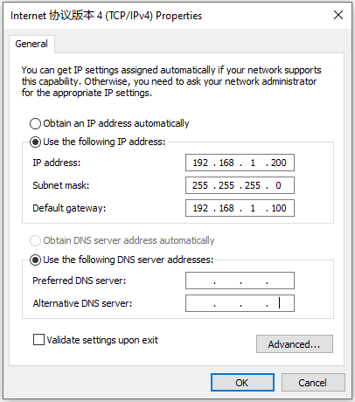
Figure 73
11.2.2 Configure the IP of machine
The factory default setting of IP address is as below:
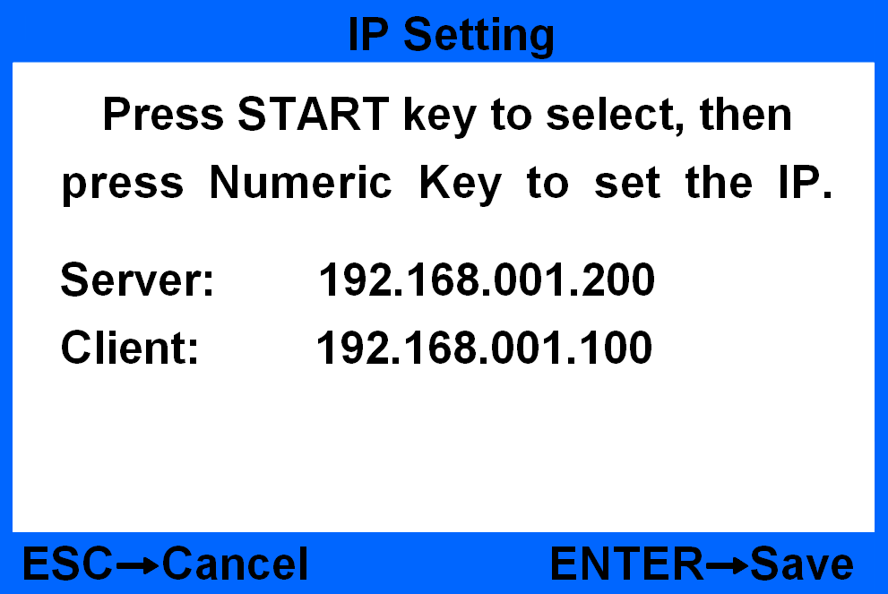
Figure 74
If it is not the IP address as Figure 74, you need to revise it, go to the user setting “User Settings” ---“5.Basic Setting”---“8.IP Address” and set the IP address.

11.3 Notes collection
There are two ways for collection, USB collection and LAN port collection, You can collect notes images and notes information

11.3.1 Error images collection
The error images collection is used when machine have frequent error code or feeding is not smooth. You can only collect notes images, and it can collect 40pcs notes at one time.
a) If you use USB to collect (it takes one minute to collect one note, so we suggest to use LAN to collect if there are many notes), please connect USB to machine(>=1G, format 32), and choose setting “Error IMG To U-Disk”, and return to main interface(you can put 40pcs notes at most and CAN NOT choose EUR mode.)
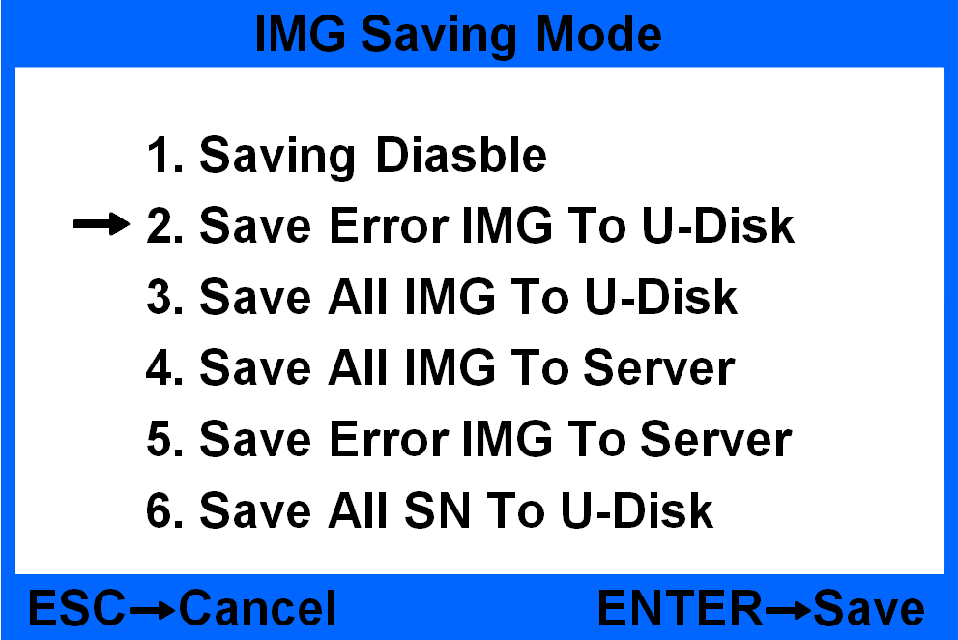
Figure 75
b) If you use PC software to collect, please connect the machine with PC, and choose “Error IMG To Server”, open the PC software, return to main interface and collect .(you can put 40pcs notes at most and CAN NOT choose EUR mode)
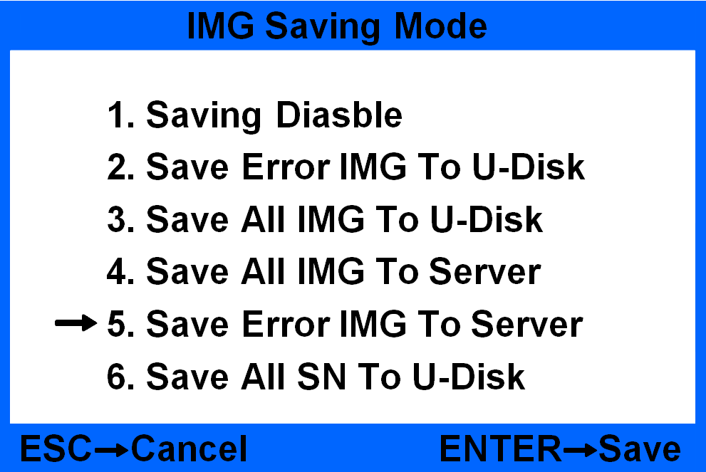
Figure 76
11.3.2 Notes information collection
Notes information collection is used to develop new currency software and analyse fake notes. The data is more complete, the operation steps is as below:
a) If you use USB to collect, please connect USB to machine(>=8G, format 32), and choose setting as below picture, and put the notes into the hopper, the notes information will be collected automatically. You can check the information in Data menu ( you CAN NOT choose EUR mode to collect).
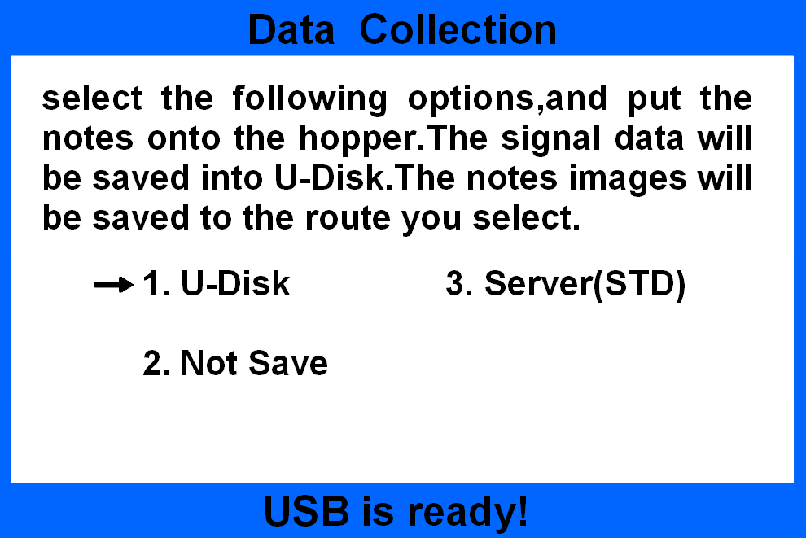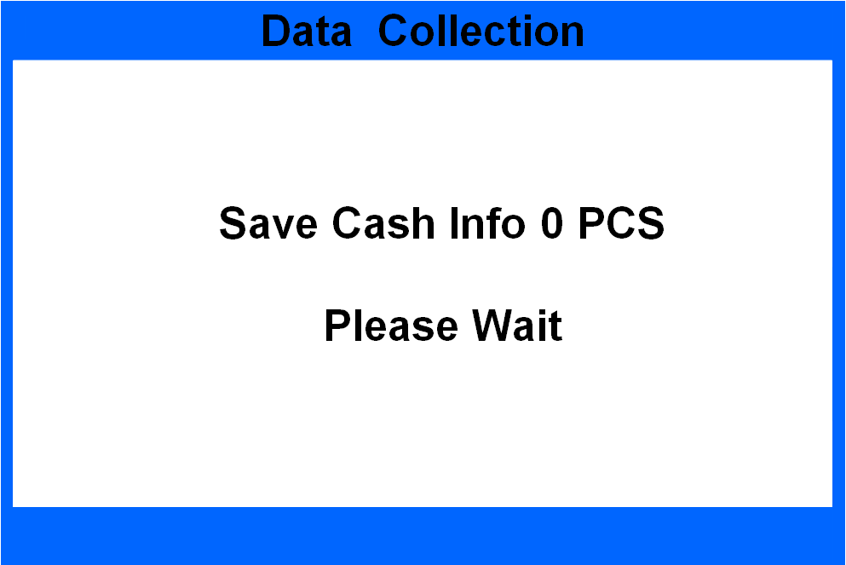
Figure 77 Figure 78
b) If you use PC software to collect, please connect the machine with PC, and choose setting as below picture, open the PC software, you can put notes into the hopper and the it will start collection automatically, you can check the information under Data menu(you CAN NOT choose EUR mode).
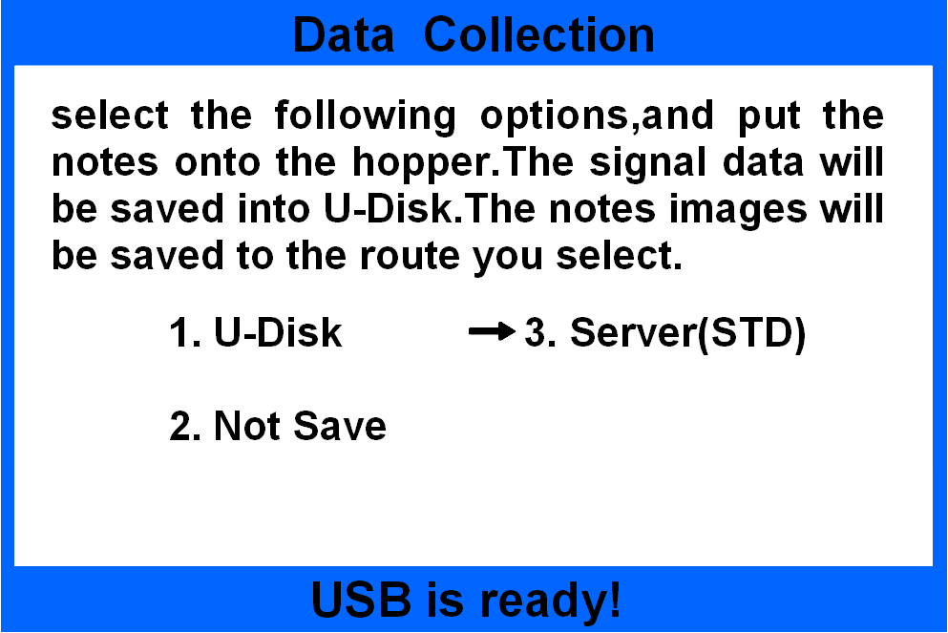
Figure 79 Figure 80
At this time, the upper computer software appears as the interface shown in Figure 81 below:
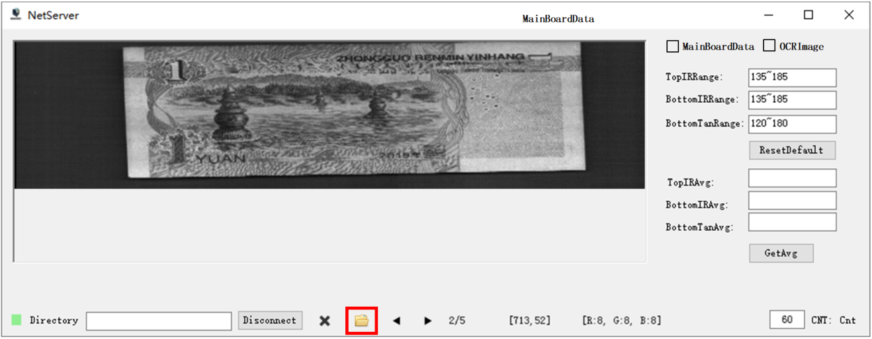
You can set specific file to save the images

open the file you can find where you save the images

Figure 81
Click the folder icon on the lower edge of the interface shown in Figure 82 to open the collected image file, as shown in Figure 82 below: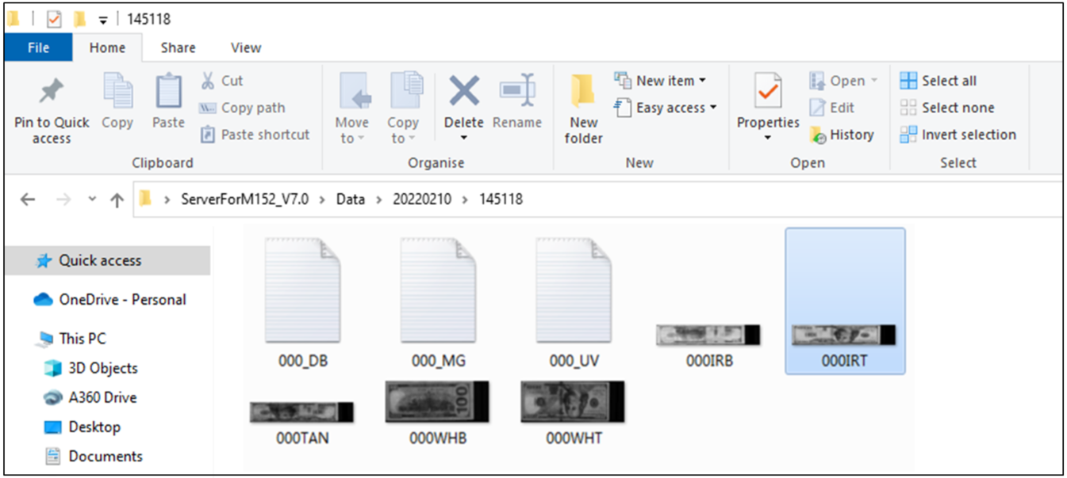
Figure 82

11.4 Notes
If there are many notes rejected during counting, you need to collect Error notes images according to 11.3.1, the maximum quantity you put on hopper is 40pcs.
For new currency development, please choose NON-EURO mode, under Data Collection interface(the machine will stop to save data every 10pcs notes). Please prepare 200pcs notes for each denomination, collect at ABCD four different orientations and save into four separate files. Please refer to 11.3.2.
For fake notes collection, you need to choose the corresponding currency, under Data Collection interface(the machine will stop to save data every 10pcs notes). Please prepare 200pcs notes for each denomination, collect at ABCD four different orientations and save into four separate files. Please refer to 11.3.2.
For Euro notes collection, no matter to collect Error notes image or collect notes information, you need to set the speed under 800 or 1000.

12. How to check the counting list
12.1 connect the serial cable
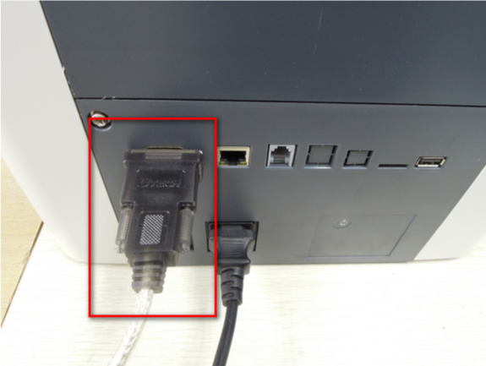
use a USB-232 adaptor, the RS232 end connects to machine, the USB end connects to PC
Figure 83
12.2 Machine setup
Turn on the machine, press SET key, choose “Peripheral Devices” and choose “2.PC”.
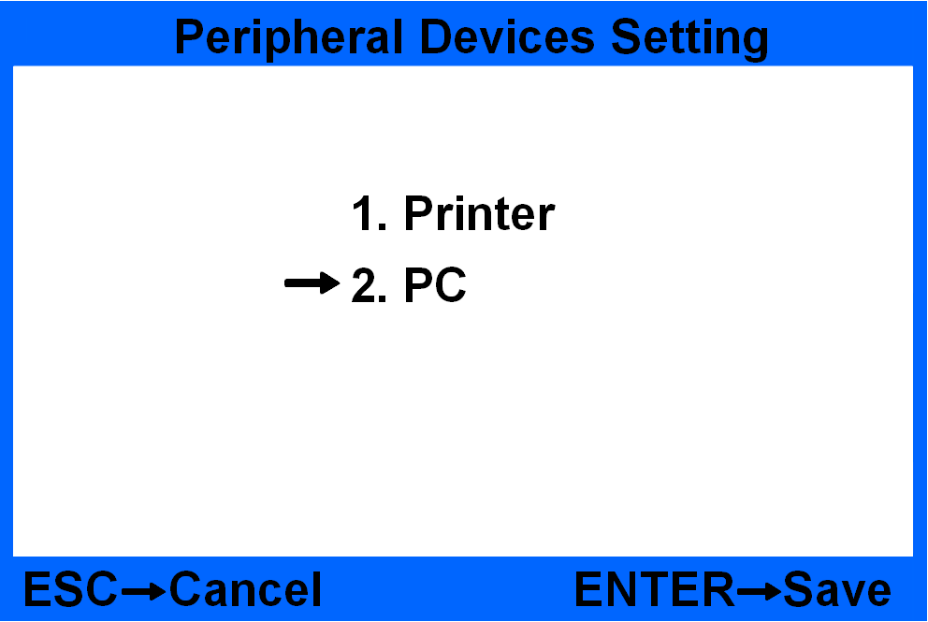
Figure 84 Figure 85

12.3 Collect list information
Open our PC software .
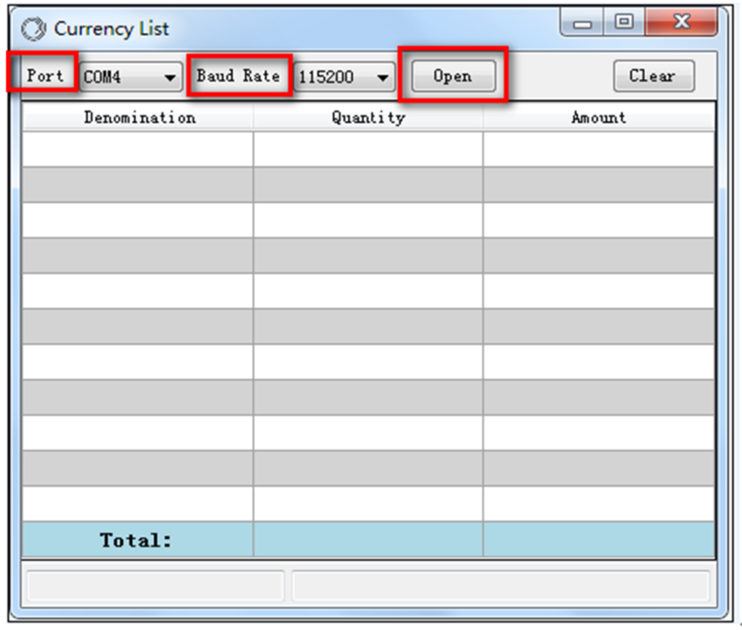
Figure 86
Choose the serial port and baud rate, press Open and the count the notes you will see the detailed information.
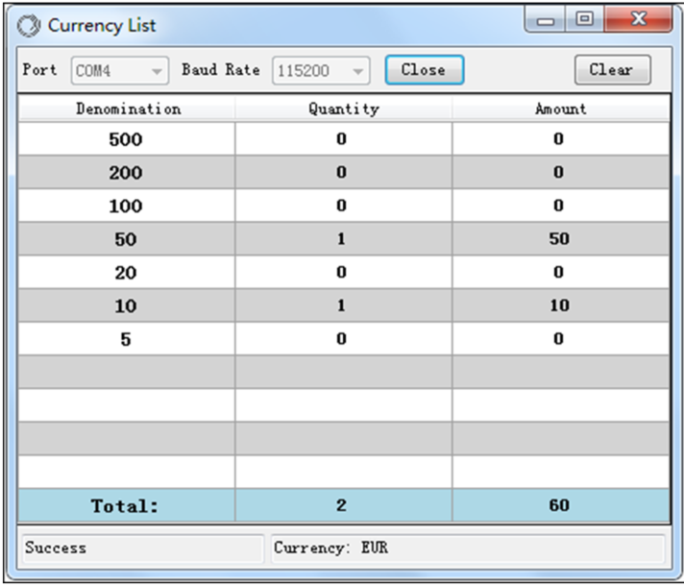
Figure 87
In the meantime there will generate a file named Data , open the file you will find the list information
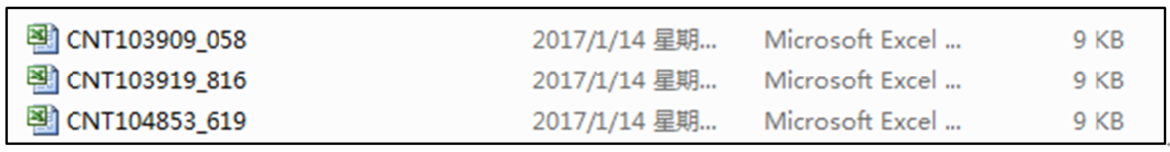
Figure 88

13. Daily Maintenance
Any dust, dirty objects or other substances can stick to the sensors and disturb the normal work of the sensors and then cause inaccurate counting result, so please clean the sensors and rollers everyday with the provided cleaning kit.
Please turn off the power switch before starting the cleaning in order to avoid any risk of electric shock or other injury.
Please do not use any chemical agent or water such as benzene, thinner which may cause the color fading or crack of the machine.

13.1 Clean the hopper sensor
Please use a brush or clean cloth to clean the hopper sensor(QT).
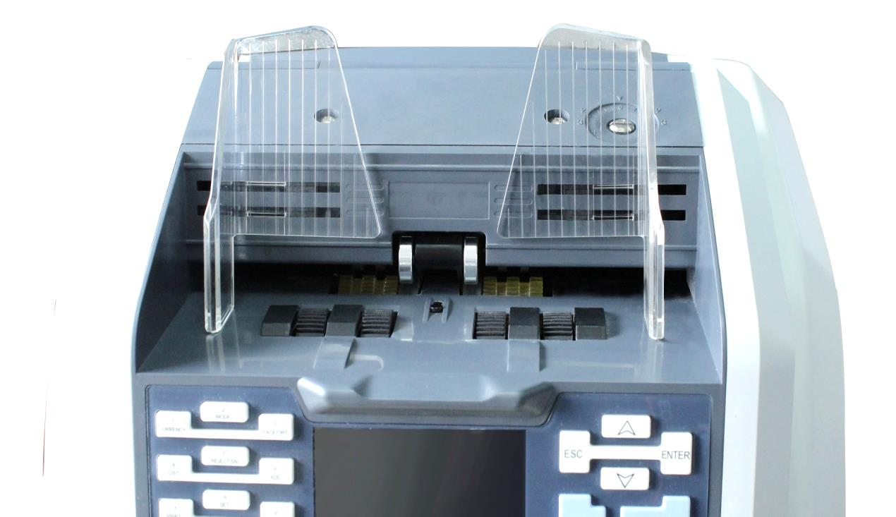
QT
Figure 89

13.2 Clean the drum roller shaft and feed roller shaft
Please use a brush or clean cloth to clean the drum roller shaft and feed roller shaft.
Figure 90

13.3 Clean the leak sensor
Please use a nylon brush or clean cloth to clean the leak sensor (ST), circled in below picture.
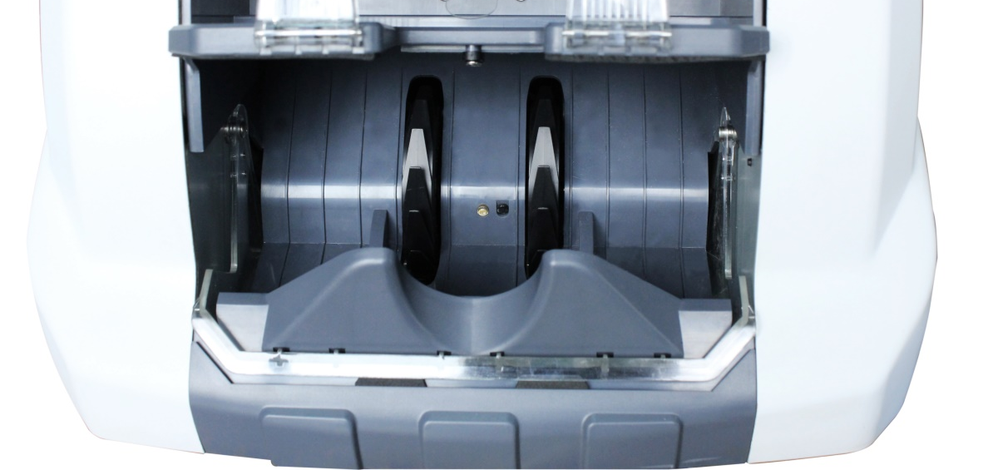
ST
Figure 91

13.4 Clean the inside sensor
1) Pull the button to open the back cover, press and push forward the metal bar to open the interior passage.
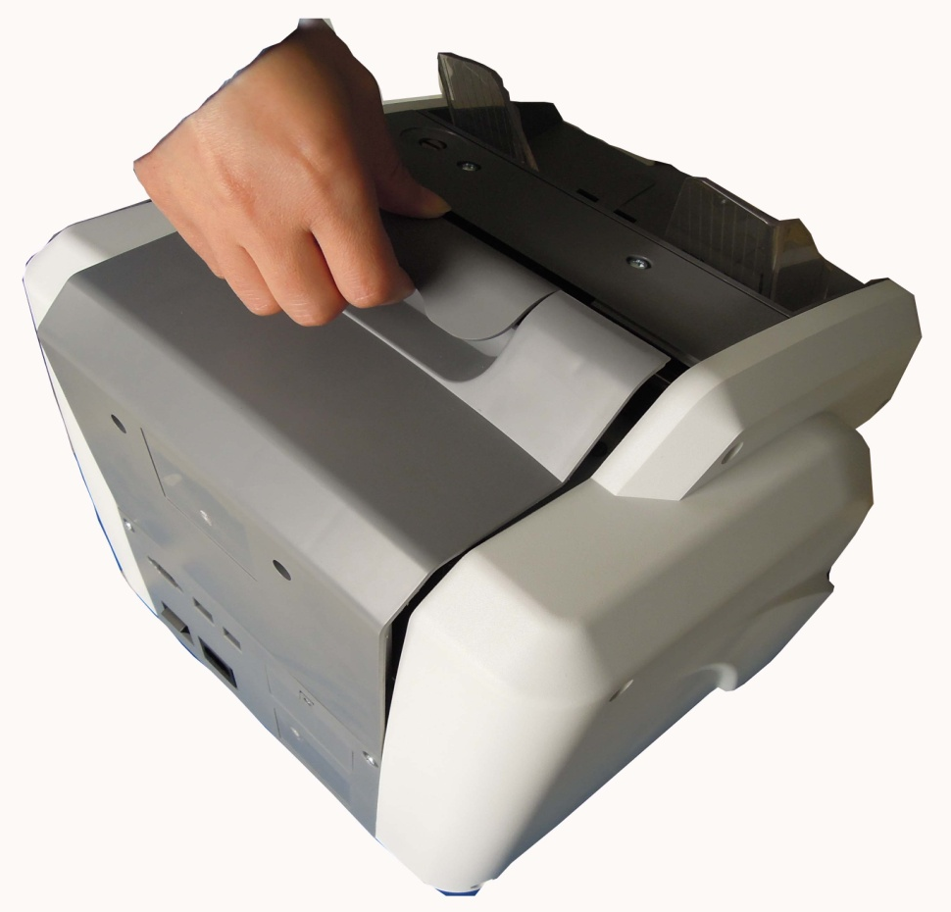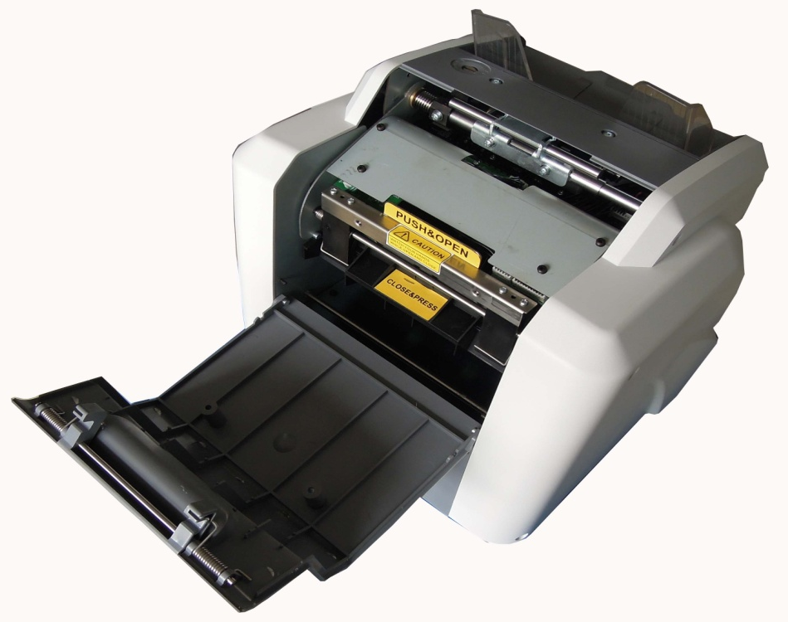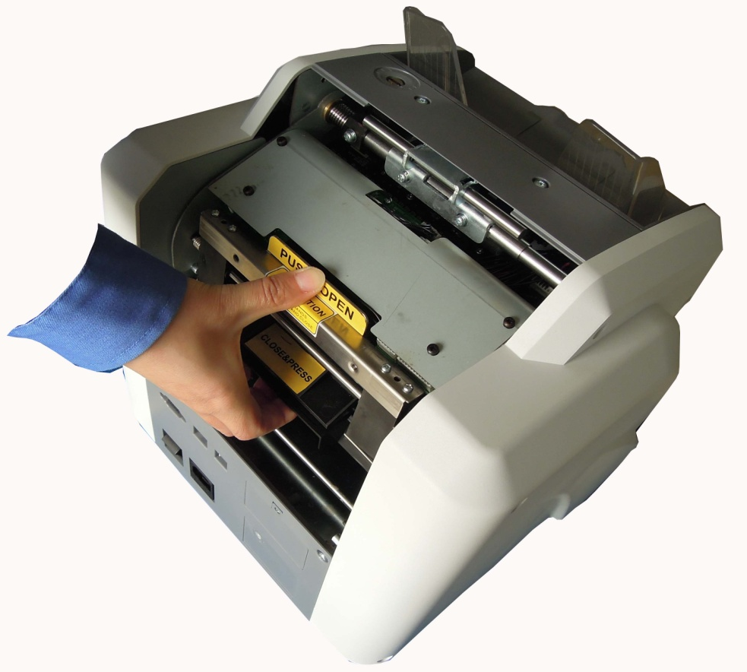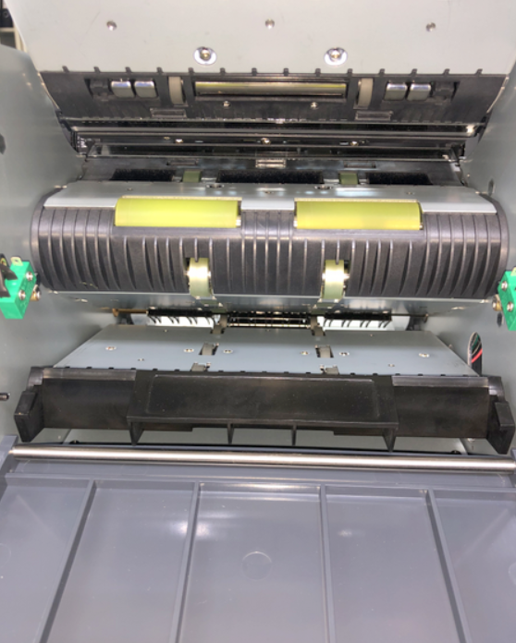
Figure 92 Figure 93 Figure 94 Figure 95
2) Clean the following sensors PS2, MG, MT, CIS and UV1.
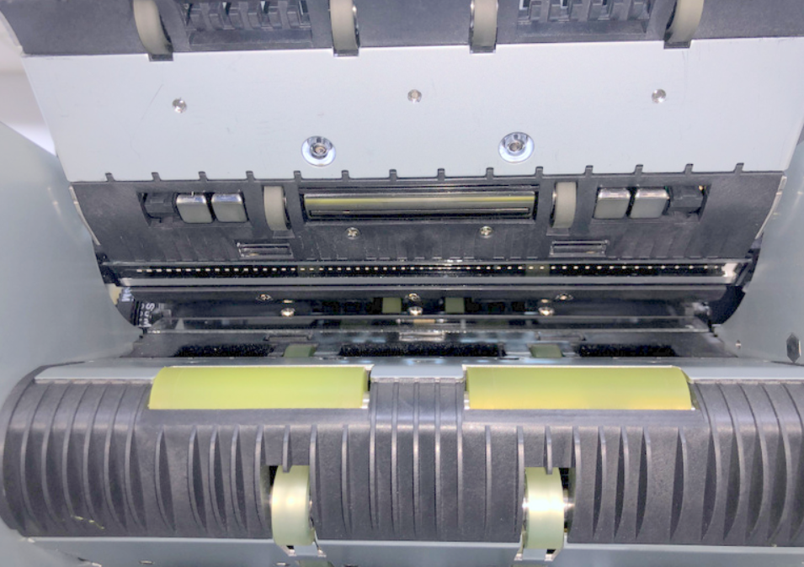
UV1L
Lower CIS
Upper CIS
UV1R
PS2
MG
MT
MG
Figure 96
3) Clean the following sensors PS1, UV2M, PS3 and brush shaft.
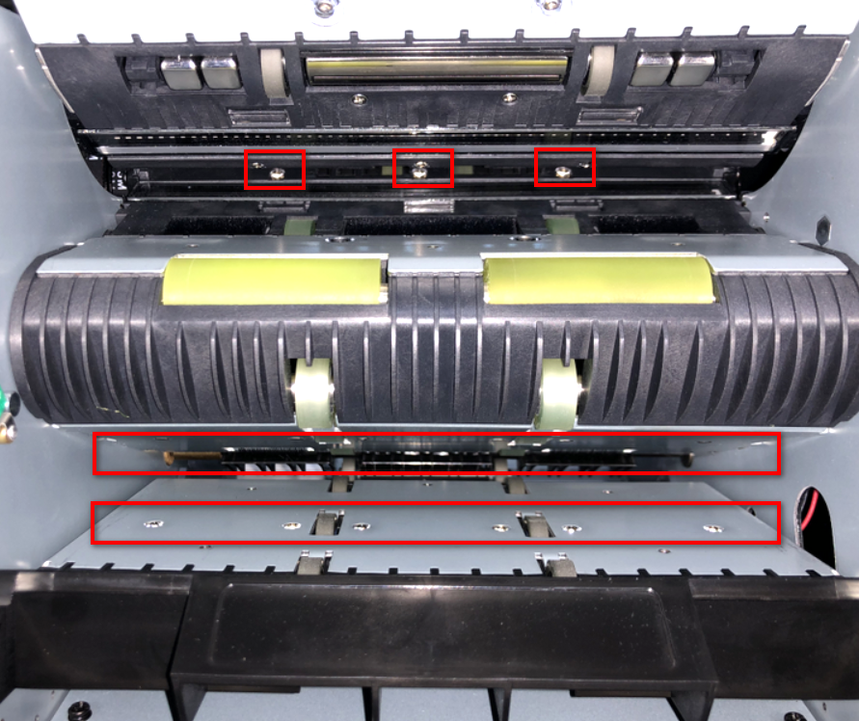
PS3
Brush shaft
UV2M
PS1
Figure 97
4) Take out the reject pocket as following picture and then clean the sensors PS4 & RJ.
5) Hold both ends of reject pocket with two hands, and pull the reject pocket out of the rack horizontally：
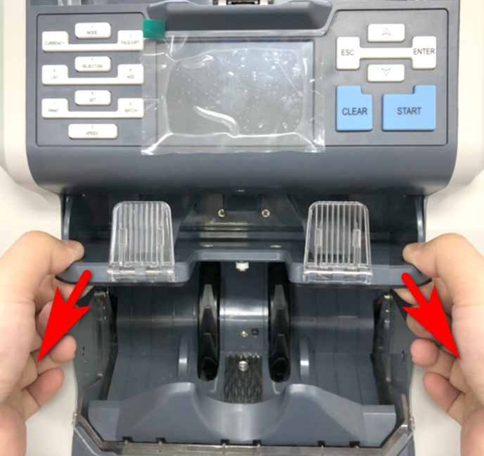
Figure 98
6) please check below the sensors that needed to be clean：
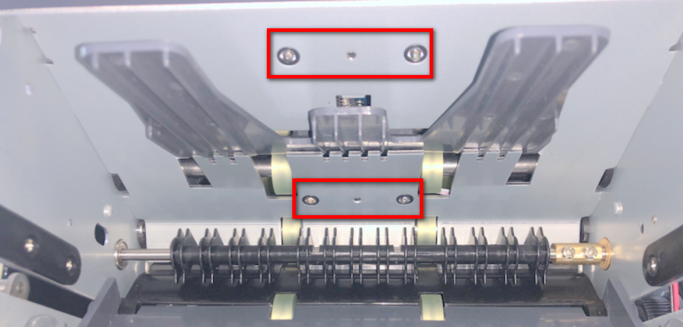
Banknotes pressing plate
Banknotes pressing plate
RJ
PS4
Figure 99
7) when the cleaning is completed, please install back reject pocket as below instructions: take the reject pocket to make it level, and press the two feet of the banknote block horizontally upward by another hand：
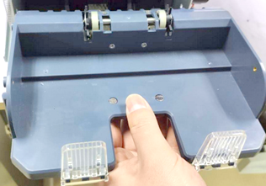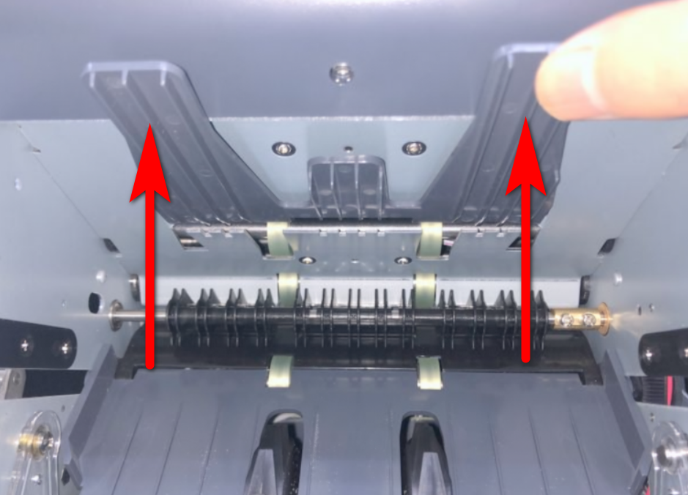
Figure 100 Figure 101
8) Align the slots on both sides of reject pocket with the rails on both sides of the rack, and load the reject pocket into the rack horizontally.
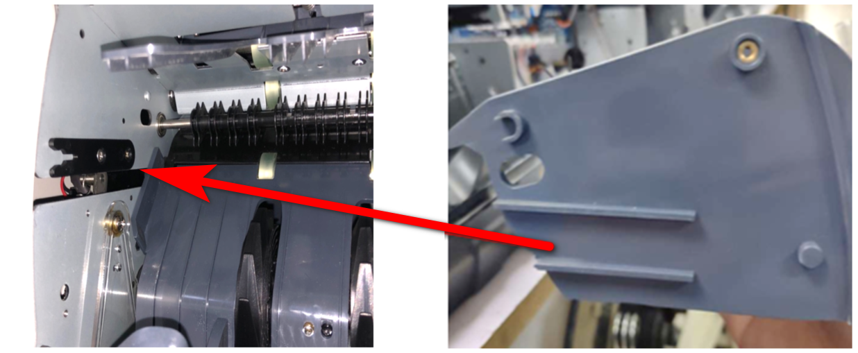
Figure 102 Figure 103
9) Push the reject pocket horizontally and frontward, and then press frontward hard by both hands until you hear the sound of "click" on the left and right sides, it indicates that the reject pocket t is assembled properly.
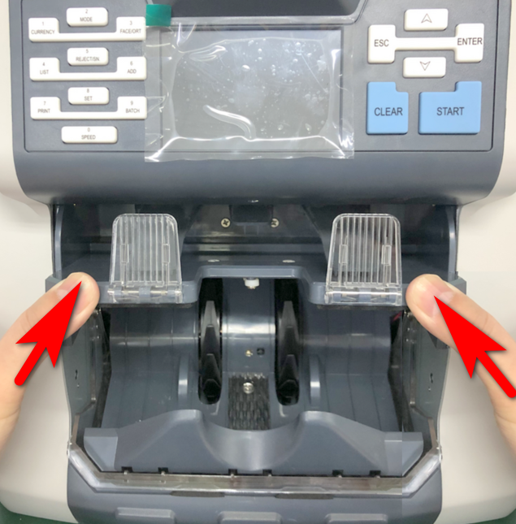
Figure 104
10) Push the feeding roller forward by hand as below first picture, at same time, check whether the two D18 pressure rollers and D22 axle wheels as below second picture are in full contact with each other. If they are in full contact with each other when complete one rotation, it indicates the assembly is in place. If there are untouched points during one rotation, it indicates that the assembly is not in place and it may cause jamming and splashing problem, please take down the reject pocket and install it again as instructions until it is in place.
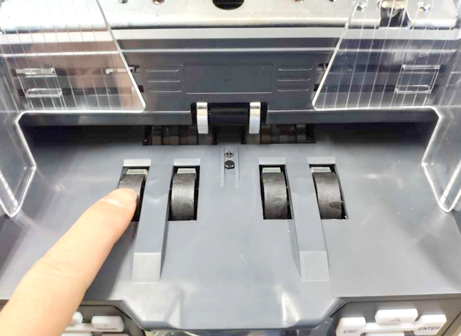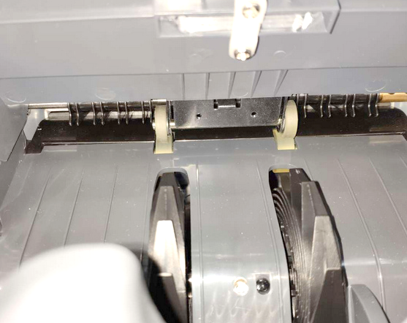
Figure 105 Figure 106

14. Accessories
1. Power Cord | 1PCS
2. Plastic Brush | 1PCS
3. Operation Manual | 1PCS
4. Ethernet cable | 1PCS
5. Check package (Option) | 1PCS
6. External Display (Option) | 1PCS
7. External Printer (Option) | 1PCS

*** In the interests of our policy of continual product improvement, specifications are subject to change without notice ***

